L-Track

Company Name: JD Software

Submitted to: Gary Clark

Submitted by: Jareth Dodson

Date Created: 10/16/2020

Version 0.3

Email: [Jareth.dodson@oit.edu](mailto:Jareth.dodson@oit.edu)

# 1. Signatory Page

____________________________ ______________

Author: Jareth Dodson Date

____________________________ ______________

Reviewer: Calvin Caldwell Date

# 2. Revision History

|  |  |  |  |  |  |
| --- | --- | --- | --- | --- | --- |
| **Author** | **Company** | **Version** | **Date** | **Filename** | **Comments** |
| Jareth Dodson | JD Software | V0.1 | 10/15//2020 | Use Case Model Tables.docx | Started Use case model Document |
| Jareth Dodson | JD Software | V0.2 | 11/7/2020 | COMPLETE Use Case Model.docx | Updated CRUD Matrix |
| Jareth Dodson | JD Software | V0.3 | 12/4/2020 | COMPLETE Use Case Model.docx | Add Sequence diagrams and Sequence scenarios |

# 3. Table of Contents

Table of Contents

1. Signatory Page 1

2. Revision History 2

3. Table of Contents 3

4. Context Diagram 4

5. Use Case Model 5

6. Actor Catalog Table 5

7. Features Verification Matric 6

8. Use Cases 7

8.1 Add Order Use Case 100 7

8.2 Delete Order Use Case 105 10

8.3 Edit Order Use Case 110 13

8.4 Set Order Status Use Case 115 16

8.5 Set Order Priority Use Case 120 19

8.6 Register Truck Driver Use Case 125 21

8.7 Register Company(Lumber and Hardware) Use Case 130 25

8.8 Share Location Use Case 135 28

8.9 Register Lumber Associate Use Case 140 30

8.10 Edit Employee Use Case 145 33

8.11 Download Mobile or Desktop Application Use Case 150 36

8.12 Delete Employee Use Case 155 39

8.13 Send and Receive Message Use Case 160 41

8.14 See Order Use Case 165 45

8.15 Login ADDS Use Case 200 47

9. CRUD Matrix 51

10. Low Fidelity UI 52

10.1 Mobile UI 52

10.2 Desktop UI 55

11. Appendix A 57

# 4. Context Diagram

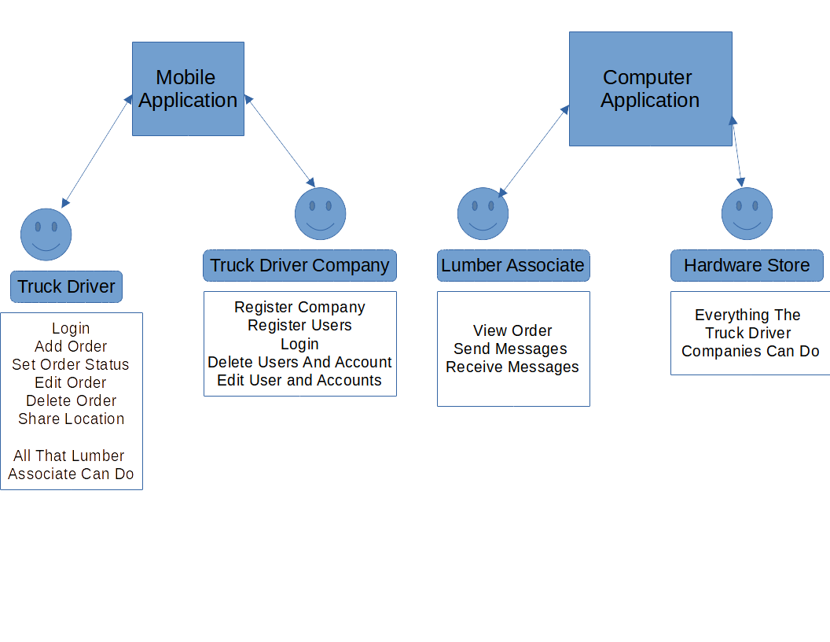

# 5. Use Case Model

|  |  |  |
| --- | --- | --- |
| Use Case ID | Use Case Name | Description |
| 100 | Add Order | Add a lumber order to applications order list |
| 105 | Delete Order | Deletes order from application order list |
| 110 | Edit Order | Edit lumber order |
| 115 | Set Order Status | Set the status of an order |
| 120 | Set Order Priority | Set Priority of order |
| 125 | Register Truck Driver | Register a truck driver to a lumber company |
| 130 | Register Company | Lumber company or Hardware store registers themselves |
| 135 | Share Location | Truck Driver shares location with lumber associate |
| 140 | Register Lumber Associate | Hardware store register lumber associate |
| 145 | Edit Employee | Truck Driver/Lumber Company and/or Lumber Associate/Hardware Store edits employee |
| 150 | Download Application | Truck Driver/Lumber Company and/or Lumber Associate/Hardware Store downloads Mobile App or Desktop application |
| 155 | Delete Employee | Truck Driver/Lumber Company and/or Lumber Associate/Hardware Store deletes employee |
| 160 | Send and Receive Message | Truck Driver and/or Truck Driver will send a message and the other party will receive it |
| 165 | See Order | Incoming order(s) will show the following information, Deliver Company, Delivery Driver Name, Order Desc, and ETA |
| 200 | Login | ADDS Use case for logging in on both the mobile and windows application |

# 6. Actor Catalog Table

|  |  |  |
| --- | --- | --- |
| Name | Type | Description |
| Truck Driver | Person | Truck Driver for lumber company |
| Company | Person | Lumber Company that delivers lumber |
| Hardware Store | Person | Hardware store that truck driver delivers lumber too |
| Lumber Associate | Person | Hardware store lumber associate that interacts with the truck driver |

# 7. Features Verification Matric

|  |  |  |
| --- | --- | --- |
| Feature #’s | Use Case ID | Use Case Name |
| 1.5 | 100 | Add Order |
| 1.5 | 105 | Delete Order |
| 1.5 | 110 | Edit Order |
| 1.5, 1.7 | 115 | Set Order Status |
| 1.5, 1.8 | 120 | Set Priority of Order |
| 1.3, 1.4 | 125 | Register Truck Driver |
| 1.3, 2.2 | 130 | Register Company |
| 1.9 | 135 | Share Location |
| 2.2, 2.4 | 140 | Register Lumber Associate |
| 1.4, 2.3 | 145 | Edit Employee |
| 1.1, 2.1 | 150 | Download Mobile Or Desktop Application |
| 1.4, 2.3 | 155 | Delete Employee |
| 1.9, 2.7 | 160 | Send and Receive Message |
| 2.6 | 165 | See Order |
| 1.6, 1.2 ,2.5 | 200 | Login ADDS |

# 8. Use Cases

## 8.1 Add Order Use Case 100

|  |  |
| --- | --- |
| **General Information** | |
| Use Case Name\Number : UC 100 Add Order  Subject Area : Truck Driver Orders  Description : Truck Driver adds lumber order to device | Responsible Analyst : Jareth Dodson |

|  |  |
| --- | --- |
| Requirements/Feature Trace | |
| REQ# | **Requirements Name and / or Short Description** |
| 1.5 | Truck drivers will be able to add, edit, delete, set status and priority of orders |

|  |  |  |
| --- | --- | --- |
| Revision History | | |
| Author | Date | Comments |
| Jareth Dodson | 9/28/2020 | First Draft |

|  |  |  |
| --- | --- | --- |
| **Insertion Points in other Use Cases (Adds Only)** | | |
| **Use Case Name** | **Use Case Number** | **Step Inserted After** |
| N/A |  |  |

|  |  |  |
| --- | --- | --- |
| **Actors** | | |
| **Actor Name** | **Person/System** | **Brief Description** |
| Truck Driver | Person | Truck Driver for a lumber company |

|  |  |
| --- | --- |
| **Pre-Conditions** | |
| # | Description |
| 1 | Has Application download |
| 2 | Has an account with lumber company |

|  |
| --- |
| **Start Stimulus** |
| Truck Driver pressed add button |

|  |  |  |  |
| --- | --- | --- | --- |
| **Use Case Main Course Steps** | | | |
| **Number** | **Description** | **Adds/Alt Name/Number** | **Bus Rule#** |
| 1 | Start login steps | Adds Login Steps UC 200 |  |
| 2 | Truck Driver presses add button |  |  |
| 3 | Application shows add order screen |  |  |
| 4 | Truck Drivers enters order information |  |  |
| 5 | Truck Driver confirms order |  |  |
| 6 | Order is added to order page |  |  |

|  |  |  |
| --- | --- | --- |
| **Exception Conditions** | | |
| **Exception Situations** | **Action(s) on Exception** | **Adds\Alt UC #** |
| Truck Drivers enter empty order | Application shows prompt that order must not be empty. Redisplays Order Screen |  |
|  |  |  |

|  |  |
| --- | --- |
| **Post-Conditions** | |
| **#** | **Description** |
| 1 | Order Added to Order Page |

|  |  |  |
| --- | --- | --- |
| **Candidate Objects** | | |
| **Class/Object Name** | **Descriptions** | **Possible**  **attributes** |
| Truck Driver | Can add, edit, delete, set status and priority of orders | Name, Address, phone number |
| Order | Holds order information | Name, Order Description, Location to, Location from |

|  |  |  |  |  |  |
| --- | --- | --- | --- | --- | --- |
| **Assumptions** | | | | | |
| **#** | **Assumption** | **Date**  **Raised** | **Raised**  **By** | **Date**  **Verified** | **Verified By** |
| 1 | N/A |  |  |  |  |
|  |  |  |  |  |  |

|  |  |  |  |  |  |
| --- | --- | --- | --- | --- | --- |
| **Issues** | | | | | |
| **#** | **Issue** | **Date**  **Raised** | **Raised**  **By** | **Date**  **Verified** | **Verified By** |
| 1 | No Truck Drivers to test application | 9/28 | Jareth Dodson |  |  |
|  |  |  |  |  |  |

|  |  |  |
| --- | --- | --- |
| **Other Comments** | | |
| **Author** | **Comment** | **Date** |
| N/A |  |  |
|  |  |  |

|  |
| --- |
| **Frequency of Execution** |
| **Frequency:**  Minimum: 1 Maximum: 10 Average: 5 (OR)Fixed:  **Per:** Hour:Day:  Week:  Month:  Other: |

|  |  |  |  |  |  |  |  |
| --- | --- | --- | --- | --- | --- | --- | --- |
| **Timing Information** | | | | | | | |
| **#** | **At/**  **Between** | **Step(s)** | **Timing**  **Unit** | **Minimum** | **Average** | **Maximum** | **Comments** |
| 1 | Between | 2, 3 | Seconds | N/A | N/A | 1 |  |

|  |  |  |  |  |  |  |
| --- | --- | --- | --- | --- | --- | --- |
| **Volume Information** | | | | | | |
| **#** | **Step #** | **Unit of**  **Measure** | **Minimum** | **Average** | **Maximum** | **Comments** |
| 1 | 4 | Kilobye |  |  | 1 |  |

**Use Case 100 Add Order Scenario**

**User presses Add button**

**Application show order screen**

**User enters information for order**

User enters information for the order

**User Confirms Order**

User adds order

System Validates all fields are filled out

Order Class checks fields

**Order is added to order page**

System Adds Order

Database adds order to database

System add order to users list

## 8.2 Delete Order Use Case 105

|  |  |
| --- | --- |
| **General Information** | |
| Use Case Name\Number : UC 105 Delete Order  Subject Area : Truck Driver Orders  Description : Truck Driver deletes lumber order from device | Responsible Analyst : Jareth Dodson |

|  |  |
| --- | --- |
| **Requirements/Feature Trace** | |
| **REQ#** | **Requirements Name and / or Short Description** |
| 1.5 | Truck drivers will be able to add, edit, delete, set status and priority of orders |

|  |  |  |
| --- | --- | --- |
| **Revision History** | | |
| **Author** | **Date** | **Comments** |
| Jareth Dodson | 10/09/2020 | First Draft |

|  |  |  |
| --- | --- | --- |
| **Insertion Points in other Use Cases (Adds Only)** | | |
| **Use Case Name** | **Use Case Number** | **Step Inserted After** |
| N/A |  |  |
|  |  |  |

|  |  |  |
| --- | --- | --- |
| **Actors** | | |
| **Actor Name** | **Person/System** | **Brief Description** |
| Truck Driver | Person | Truck Driver for a lumber company |
|  |  |  |
|  |  |  |

|  |  |
| --- | --- |
| **Pre-Conditions** | |
| # | Description |
| 1 | Has Application downloaded |
| 2 | Has an account with lumber company |
| 3 | Must have an order |

|  |
| --- |
| **Start Stimulus** |
| Truck Driver pressed delete button |

|  |  |  |  |
| --- | --- | --- | --- |
| **Use Case Main Course Steps** | | | |
| **Number** | **Description** | **Adds/Alt Name/Number** | **Bus Rule#** |
| 1 | Start login steps | Adds Login Steps UC 200 |  |
| 2 | Truck Driver presses delete button |  |  |
| 3 | Application shows delete confirmation alert |  |  |
| 4 | Truck Drivers presses confirm to delete order |  |  |
| 5 | Order is deleted from order page |  |  |

|  |  |  |
| --- | --- | --- |
| **Exception Conditions** | | |
| **Exception Situations** | **Action(s) on Exception** | **Adds\Alt UC #** |
|  |  |  |

|  |  |
| --- | --- |
| **Post-Conditions** | |
| **#** | **Description** |
| 1 | Order is Deleted from Order Page |

|  |  |  |
| --- | --- | --- |
| **Candidate Objects** | | |
| **Class/Object Name** | **Descriptions** | **Possible**  **attributes** |
| Truck Driver | Can add, edit, delete, set status and priority of orders | Name, Address, phone number |
| Order | Holds order information | Name, Order Description, Location to, Location from |

|  |  |  |  |  |  |
| --- | --- | --- | --- | --- | --- |
| **Assumptions** | | | | | |
| **#** | **Assumption** | **Date**  **Raised** | **Raised**  **By** | **Date**  **Verified** | **Verified By** |
| 1 | N/A |  |  |  |  |
|  |  |  |  |  |  |

|  |  |  |  |  |  |
| --- | --- | --- | --- | --- | --- |
| **Issues** | | | | | |
| **#** | **Issue** | **Date**  **Raised** | **Raised**  **By** | **Date**  **Verified** | **Verified By** |
| 1 | N/A |  |  |  |  |

|  |  |  |
| --- | --- | --- |
| **Other Comments** | | |
| **Author** | **Comment** | **Date** |
| N/A |  |  |
|  |  |  |

|  |
| --- |
| **Frequency of Execution** |
| **Frequency:**  Minimum: 1 Maximum: 10 Average: 5 (OR)Fixed:  **Per:** Hour:Day:  Week:  Month:  Other: |

|  |  |  |  |  |  |  |  |
| --- | --- | --- | --- | --- | --- | --- | --- |
| **Timing Information** | | | | | | | |
| **#** | **At/**  **Between** | **Step(s)** | **Timing**  **Unit** | **Minimum** | **Average** | **Maximum** | **Comments** |
| 1 | Between | 2, 3 | Seconds | N/A | N/A | 1 |  |

|  |  |  |  |  |  |  |
| --- | --- | --- | --- | --- | --- | --- |
| **Volume Information** | | | | | | |
| **#** | **Step #** | **Unit of**  **Measure** | **Minimum** | **Average** | **Maximum** | **Comments** |
| 1 | 5 | Kilobyte |  |  | 1 |  |

**Use Case 105 Delete Order scenario**

**Truck Driver presses delete button**

Starts deletion process

**Application shows delete confirmation alert**

**Truck drivers presses confirm to delete order**

Order gets deleted from database

Order gets deleted from order list

**Order is deleted from order page**

## 8.3 Edit Order Use Case 110

|  |  |
| --- | --- |
| **General Information** | |
| Use Case Name\Number : UC 110 Edit Order  Subject Area : Truck Driver Orders  Description : Truck Driver edits lumber order on device | Responsible Analyst : Jareth Dodson |

|  |  |
| --- | --- |
| **Requirements/Feature Trace** | |
| **REQ#** | **Requirements Name and / or Short Description** |
| 1.5 | Truck drivers will be able to add, edit, delete, set status and priority of orders |

|  |  |  |
| --- | --- | --- |
| **Revision History** | | |
| **Author** | **Date** | **Comments** |
| Jareth Dodson | 10/09/2020 | First Draft |

|  |  |  |
| --- | --- | --- |
| **Insertion Points in other Use Cases (Adds Only)** | | |
| **Use Case Name** | **Use Case Number** | **Step Inserted After** |
| N/A |  |  |
|  |  |  |

|  |  |  |
| --- | --- | --- |
| **Actors** | | |
| **Actor Name** | **Person/System** | **Brief Description** |
| Truck Driver | Person | Truck Driver for a lumber company |

|  |  |
| --- | --- |
| **Pre-Conditions** | |
| # | Description |
| 1 | Has Application download |
| 2 | Has an account with lumber company |
| 3 | Has added an order |

|  |
| --- |
| **Start Stimulus** |
| Truck Driver pressed edit button |

|  |  |  |  |
| --- | --- | --- | --- |
| **Use Case Main Course Steps** | | | |
| **Number** | **Description** | **Adds/Alt Name/Number** | **Bus Rule#** |
| 1 | Start login steps | Adds Login Steps UC 200 |  |
| 2 | Truck Driver pressed edit button |  |  |
| 3 | Application shows Edit Order Page |  |  |
| 4 | Truck Drivers Edits Order |  |  |
| 5 | Truck Drivers confirms Edits |  |  |
| 6 | Order is edited |  |  |

|  |  |  |
| --- | --- | --- |
| **Exception Conditions** | | |
| **Exception Situations** | **Action(s) on Exception** | **Adds\Alt UC #** |
|  |  |  |

|  |  |
| --- | --- |
| **Post-Conditions** | |
| **#** | **Description** |
| 1 | Order has been Edited |

|  |  |  |
| --- | --- | --- |
| **Candidate Objects** | | |
| **Class/Object Name** | **Descriptions** | **Possible**  **attributes** |
| Truck Driver | Can add, edit, delete, set status and priority of orders | Name, Address, phone number |
| Order | Holds order information | Name, Order Description, Location to, Location from |

|  |  |  |  |  |  |
| --- | --- | --- | --- | --- | --- |
| **Assumptions** | | | | | |
| **#** | **Assumption** | **Date**  **Raised** | **Raised**  **By** | **Date**  **Verified** | **Verified By** |
| 1 | N/A |  |  |  |  |

|  |  |  |  |  |  |
| --- | --- | --- | --- | --- | --- |
| **Issues** | | | | | |
| **#** | **Issue** | **Date**  **Raised** | **Raised**  **By** | **Date**  **Verified** | **Verified By** |
| 1 | N/A |  |  |  |  |

|  |  |  |
| --- | --- | --- |
| **Other Comments** | | |
| **Author** | **Comment** | **Date** |
| N/A |  |  |

|  |
| --- |
| **Frequency of Execution** |
| **Frequency:**  Minimum: 1 Maximum: 10 Average: 3 (OR)Fixed:  **Per:** Hour:Day:  Week:  Month:  Other: |

|  |  |  |  |  |  |  |  |
| --- | --- | --- | --- | --- | --- | --- | --- |
| **Timing Information** | | | | | | | |
| **#** | **At/**  **Between** | **Step(s)** | **Timing**  **Unit** | **Minimum** | **Average** | **Maximum** | **Comments** |
| 1 | Between | 2, 3 | Seconds | N/A | N/A | 1 |  |

|  |  |  |  |  |  |  |
| --- | --- | --- | --- | --- | --- | --- |
| **Volume Information** | | | | | | |
| **#** | **Step #** | **Unit of**  **Measure** | **Minimum** | **Average** | **Maximum** | **Comments** |
| 1 | N/A |  |  |  |  |  |

**Use Case 110 Edit Order scenario**

**User presses edit button**

User is ready to edit order

**Application shows edit order page**

**User edits order**

**User confirms edits**

System validates order

System checks fields of order

Order gets edited

Database order gets edited

Order list gets updated

**Order is edited**

## 8.4 Set Order Status Use Case 115

|  |  |
| --- | --- |
| **General Information** | |
| Use Case Name\Number : UC 115 Set Order Status  Subject Area : Truck Driver Orders  Description : Truck Drivers | Responsible Analyst : Jareth Dodson |

|  |  |
| --- | --- |
| **Requirements/Feature Trace** | |
| **REQ#** | **Requirements Name and / or Short Description** |
| 1.5 | Truck drivers will be able to add, edit, delete, set status and priority of orders |
| 1.7 | Truck drivers can set the status of the orders to the following status’ |

|  |  |  |
| --- | --- | --- |
| **Revision History** | | |
| **Author** | **Date** | **Comments** |
| Jareth Dodson | 10/11/2020 | First Draft |

|  |  |  |
| --- | --- | --- |
| **Insertion Points in other Use Cases (Adds Only)** | | |
| **Use Case Name** | **Use Case Number** | **Step Inserted After** |
| N/A |  |  |
|  |  |  |

|  |  |  |
| --- | --- | --- |
| **Actors** | | |
| **Actor Name** | **Person/System** | **Brief Description** |
| Truck Driver | Person | Truck Driver for a lumber company |

|  |  |
| --- | --- |
| **Pre-Conditions** | |
| # | Description |
| 1 | Has Application download |
| 2 | Has an account with lumber company |

|  |
| --- |
| **Start Stimulus** |
| Truck Drivers presses edit status button |

|  |  |  |  |
| --- | --- | --- | --- |
| **Use Case Main Course Steps** | | | |
| **Number** | **Description** | **Adds/Alt Name/Number** | **Bus Rule#** |
| 1 | Start login steps | Adds Login Steps UC 200 |  |
| 2 | Truck Drivers presses edit status button |  |  |
| 3 | Application shows edit status screen |  |  |
| 4 | Truck Drivers Edits status of Order |  |  |
| 5 | Orders status is updated |  |  |

|  |  |  |
| --- | --- | --- |
| **Exception Conditions** | | |
| **Exception Situations** | **Action(s) on Exception** | **Adds\Alt UC #** |
|  |  |  |

|  |  |
| --- | --- |
| **Post-Conditions** | |
| **#** | **Description** |
| 1 | Orders status is updated |
|  |  |

|  |  |  |
| --- | --- | --- |
| **Candidate Objects** | | |
| **Class/Object Name** | **Descriptions** | **Possible**  **attributes** |
| Truck Driver | Can add, edit, delete, set status and priority of orders | Name, Address, phone number |
| Order | Holds order information | Name, Order Description, Location to, Location from |

|  |  |  |  |  |  |
| --- | --- | --- | --- | --- | --- |
| **Assumptions** | | | | | |
| **#** | **Assumption** | **Date**  **Raised** | **Raised**  **By** | **Date**  **Verified** | **Verified By** |
| 1 | N/A |  |  |  |  |
|  |  |  |  |  |  |

|  |  |  |  |  |  |
| --- | --- | --- | --- | --- | --- |
| **Issues** | | | | | |
| **#** | **Issue** | **Date**  **Raised** | **Raised**  **By** | **Date**  **Verified** | **Verified By** |
| 1 | N/A |  |  |  |  |
|  |  |  |  |  |  |

|  |  |  |
| --- | --- | --- |
| **Other Comments** | | |
| **Author** | **Comment** | **Date** |
| N/A |  |  |
|  |  |  |

|  |
| --- |
| **Frequency of Execution** |
| **Frequency:**  Minimum: 1 Maximum: 10 Average: 5 (OR)Fixed:  **Per:** Hour:Day:  Week:  Month:  Other: |

|  |  |  |  |  |  |  |  |
| --- | --- | --- | --- | --- | --- | --- | --- |
| **Timing Information** | | | | | | | |
| **#** | **At/**  **Between** | **Step(s)** | **Timing**  **Unit** | **Minimum** | **Average** | **Maximum** | **Comments** |
| 1 | Between | 2, 3 | Seconds | N/A | N/A | 1 | Don’t want user to close application while updating |

|  |  |  |  |  |  |  |
| --- | --- | --- | --- | --- | --- | --- |
| **Volume Information** | | | | | | |
| **#** | **Step #** | **Unit of**  **Measure** | **Minimum** | **Average** | **Maximum** | **Comments** |
| 1 | N/A |  |  |  |  |  |

**Use Case 115 Set Order Status scenario**

**Truck Drivers presses edit status button**

**Application shows edit status screen**

**Truck drivers edits status of order**

System updates Database order

System updates order list

**Order status is updated**

## 8.5 Set Order Priority Use Case 120

|  |  |
| --- | --- |
| **General Information** | |
| Use Case Name\Number : UC 120 Set Order Priority  Subject Area : Truck Drivers Orders  Description : Truck Drivers sets priority of order | Responsible Analyst : Jareth Dodson |

|  |  |
| --- | --- |
| **Requirements/Feature Trace** | |
| **REQ#** | **Requirements Name and / or Short Description** |
| 1.8 | Truck Drivers must be able to set priority of order |

|  |  |  |
| --- | --- | --- |
| **Revision History** | | |
| **Author** | **Date** | **Comments** |
| Jareth Dodson | 10/12/2020 | First Draft |

|  |  |  |
| --- | --- | --- |
| **Insertion Points in other Use Cases (Adds Only)** | | |
| **Use Case Name** | **Use Case Number** | **Step Inserted After** |
| N/A |  |  |
|  |  |  |

|  |  |  |
| --- | --- | --- |
| **Actors** | | |
| **Actor Name** | **Person/System** | **Brief Description** |
| Truck Driver | Person | Truck Driver for a lumber company |

|  |  |
| --- | --- |
| **Pre-Conditions** | |
| # | Description |
| 1 | Has Application download |
| 2 | Has an account with lumber company |
| 3 | Has orders in order list |

|  |
| --- |
| **Start Stimulus** |
| Truck Driver pressed edit priority button |

|  |  |  |  |
| --- | --- | --- | --- |
| **Use Case Main Course Steps** | | | |
| **Number** | **Description** | **Adds/Alt Name/Number** | **Bus Rule#** |
| 1 | Start login steps | Adds Login Steps UC 200 |  |
| 2 | Truck Driver presses edit priority button |  |  |
| 3 | Application shows list of priority status’ |  |  |
| 4 | Truck Drivers chooses priority status |  |  |
| 5 | Order gets moved in list depending on priority |  |  |

|  |  |  |
| --- | --- | --- |
| **Exception Conditions** | | |
| **Exception Situations** | **Action(s) on Exception** | **Adds\Alt UC #** |
|  |  |  |

|  |  |
| --- | --- |
| **Post-Conditions** | |
| **#** | **Description** |
| 1 | Order priority has been changed |
|  |  |

|  |  |  |
| --- | --- | --- |
| **Candidate Objects** | | |
| **Class/Object Name** | **Descriptions** | **Possible**  **attributes** |
| Truck Driver | Can add, edit, delete, set status and priority of orders | Name, Address, phone number |
| Order | Holds order information | Name, Order Description, Location to, Location from |

|  |  |  |  |  |  |
| --- | --- | --- | --- | --- | --- |
| **Assumptions** | | | | | |
| **#** | **Assumption** | **Date**  **Raised** | **Raised**  **By** | **Date**  **Verified** | **Verified By** |
| 1 | N/A |  |  |  |  |
|  |  |  |  |  |  |

|  |  |  |  |  |  |
| --- | --- | --- | --- | --- | --- |
| **Issues** | | | | | |
| **#** | **Issue** | **Date**  **Raised** | **Raised**  **By** | **Date**  **Verified** | **Verified By** |
| 1 | N/A |  |  |  |  |
|  |  |  |  |  |  |

|  |  |  |
| --- | --- | --- |
| **Other Comments** | | |
| **Author** | **Comment** | **Date** |
| N/A |  |  |
|  |  |  |

|  |
| --- |
| **Frequency of Execution** |
| **Frequency:**  Minimum: 1 Maximum: 10 Average: 5 (OR)Fixed:  **Per:** Hour:Day:  Week:  Month:  Other: |

|  |  |  |  |  |  |  |  |
| --- | --- | --- | --- | --- | --- | --- | --- |
| **Timing Information** | | | | | | | |
| **#** | **At/**  **Between** | **Step(s)** | **Timing**  **Unit** | **Minimum** | **Average** | **Maximum** | **Comments** |
| 1 | At | 5 | Seconds | N/A | N/A | 1 |  |

|  |  |  |  |  |  |  |
| --- | --- | --- | --- | --- | --- | --- |
| **Volume Information** | | | | | | |
| **#** | **Step #** | **Unit of**  **Measure** | **Minimum** | **Average** | **Maximum** | **Comments** |
| 1 | N/A |  |  |  |  |  |

**Use Case 120 Set Order Priority scenario**

**Truck Drivers presses edit priority button**

**Application shows list of priority status’**

**Truck drivers chooses priority status**

System updates Database order

System updates order list

**Order gets moved in list depending on priority**

## 

## 8.6 Register Truck Driver Use Case 125

|  |  |
| --- | --- |
| **General Information** | |
| Use Case Name\Number : UC 125 Register Truck Driver  Subject Area : Company Truck Drivers  Description : Company registers truck drivers | Responsible Analyst : Jareth Dodson |

|  |  |
| --- | --- |
| **Requirements/Feature Trace** | |
| **REQ#** | **Requirements Name and / or Short Description** |
| 1.3 | Lumber companies must be able to register and log in for companies and drivers |
| 1.4 | Companies must be able to add/edit/delete drivers and the company’s details (Name, address, phone number) |

|  |  |  |
| --- | --- | --- |
| **Revision History** | | |
| **Author** | **Date** | **Comments** |
| Jareth Dodson | 10/12/2020 | First Draft |

|  |  |  |
| --- | --- | --- |
| **Insertion Points in other Use Cases (Adds Only)** | | |
| **Use Case Name** | **Use Case Number** | **Step Inserted After** |
| N/A |  |  |

|  |  |  |
| --- | --- | --- |
| **Actors** | | |
| **Actor Name** | **Person/System** | **Brief Description** |
| Truck Driver Company | Person | Company that truck driver works for |
| Truck Driver | Person | Truck Driver for a lumber company |

|  |  |
| --- | --- |
| **Pre-Conditions** | |
| # | Description |
| 1 | Has Application downloaded |
| 2 | Has registered company in application |

|  |
| --- |
| **Start Stimulus** |
| Company presses Register truck driver button |

|  |  |  |  |
| --- | --- | --- | --- |
| **Use Case Main Course Steps** | | | |
| **Number** | **Description** | **Adds/Alt Name/Number** | **Bus Rule#** |
| 1 | Start login steps | Adds Login Steps UC 200 |  |
| 2 | Company pressed Register button |  |  |
| 3 | Company enters Truck Driver information |  |  |
| 4 | Company Confirms Truck Driver |  |  |
| 5 | Truck Driver is added to list of Company Drivers |  |  |

|  |  |  |
| --- | --- | --- |
| **Exception Conditions** | | |
| **Exception Situations** | **Action(s) on Exception** | **Adds\Alt UC #** |
| Company Registers Empty Truck Driver | Pop-up message saying that all fields must include information |  |

|  |  |
| --- | --- |
| **Post-Conditions** | |
| **#** | **Description** |
| 1 | Truck Driver is added to company driver list |
|  |  |

|  |  |  |
| --- | --- | --- |
| **Candidate Objects** | | |
| **Class/Object Name** | **Descriptions** | **Possible**  **attributes** |
| Lumber Company | Lumber company that registers truck drivers | Name, Address, Phone Number, Number of truck drivers, List of truck drivers |
| Truck Driver | Truck driver for lumber company | Name, Address, phone number |

|  |  |  |  |  |  |
| --- | --- | --- | --- | --- | --- |
| **Assumptions** | | | | | |
| **#** | **Assumption** | **Date**  **Raised** | **Raised**  **By** | **Date**  **Verified** | **Verified By** |
| 1 | N/A |  |  |  |  |

|  |  |  |  |  |  |
| --- | --- | --- | --- | --- | --- |
| **Issues** | | | | | |
| **#** | **Issue** | **Date**  **Raised** | **Raised**  **By** | **Date**  **Verified** | **Verified By** |
| 1 | N/A |  |  |  |  |

|  |  |  |
| --- | --- | --- |
| **Other Comments** | | |
| **Author** | **Comment** | **Date** |
| N/A |  |  |
|  |  |  |

|  |
| --- |
| **Frequency of Execution** |
| **Frequency:**  Minimum: 1 Maximum: 5 Average: 2 (OR)Fixed:  **Per:** Hour:Day:  Week:  Month:  Other: |

|  |  |  |  |  |  |  |  |
| --- | --- | --- | --- | --- | --- | --- | --- |
| **Timing Information** | | | | | | | |
| **#** | **At/**  **Between** | **Step(s)** | **Timing**  **Unit** | **Minimum** | **Average** | **Maximum** | **Comments** |
| 1 | Between | 4,5 | Secnds | N/A | N/A | 1 |  |

|  |  |  |  |  |  |  |
| --- | --- | --- | --- | --- | --- | --- |
| **Volume Information** | | | | | | |
| **#** | **Step #** | **Unit of**  **Measure** | **Minimum** | **Average** | **Maximum** | **Comments** |
| 1 | N/A |  |  |  |  |  |

**Use Case 125 Register Truck Driver scenario**

**Company pressed Register button**

**Company enters truck driver information**

System prompts Username

System Checks Username

System prompts Password

System Checks Password

System Prompts for Password confirmation

**Company confirms truck driver**

System registers user to database

**Truck driver is added to list of company drivers**

## 8.7 Register Company(Lumber and Hardware) Use Case 130

|  |  |
| --- | --- |
| **General Information** | |
| Use Case Name\Number : UC 130 Register Company  Subject Area : Lumber Company or Hardware Store  Description : Lumber company or Hardware store registers themselves | Responsible Analyst : Jareth Dodson |

|  |  |
| --- | --- |
| **Requirements/Feature Trace** | |
| **REQ#** | **Requirements Name and / or Short Description** |
| 1.3 | Lumber companies must be able to register and log in for companies and drivers |
| 2.2 | Hardware store or companies will be able to register and login a company and employees |

|  |  |  |
| --- | --- | --- |
| **Revision History** | | |
| **Author** | **Date** | **Comments** |
| Jareth Dodson | 10/12/2020 | First Draft |
| Jareth Dodson | 10/14/2020 | Added Hardware store. Hardware store follows same registering process |

|  |  |  |
| --- | --- | --- |
| **Insertion Points in other Use Cases (Adds Only)** | | |
| **Use Case Name** | **Use Case Number** | **Step Inserted After** |
| N/A |  |  |
|  |  |  |

|  |  |  |
| --- | --- | --- |
| **Actors** | | |
| **Actor Name** | **Person/System** | **Brief Description** |
| Lumber Company | Person | Company that registers Truck Drivers |
| Hardware Store | Person | Hardware store that registers and handles lumber associates |

|  |  |
| --- | --- |
| **Pre-Conditions** | |
| # | Description |
| 1 | Must have application downloaded |

|  |
| --- |
| **Start Stimulus** |
| Company/Hardware Store presses register button on main page |

|  |  |  |  |
| --- | --- | --- | --- |
| **Use Case Main Course Steps** | | | |
| **Number** | **Description** | **Adds/Alt Name/Number** | **Bus Rule#** |
| 1 | Company pressed register button |  |  |
| 2 | Company enters company information |  |  |
| 3 | Company Confirms information |  |  |
| 4 | Company is registered |  |  |

|  |  |  |
| --- | --- | --- |
| **Exception Conditions** | | |
| **Exception Situations** | **Action(s) on Exception** | **Adds\Alt UC #** |
| Empty Information fields | Pop-up that says one or more fields are empty |  |

|  |  |
| --- | --- |
| **Post-Conditions** | |
| **#** | **Description** |
| 1 | Company is now a registered user |

|  |  |  |
| --- | --- | --- |
| **Candidate Objects** | | |
| **Class/Object Name** | **Descriptions** | **Possible**  **attributes** |
| Lumber Company | Lumber company that registers and tracks Truck Drivers | Name, Phone number, Address, Number of Truck Drivers, List of truck drivers |
| Hardware Store | Hardware store that registers and maintains Lumber Associate | Name, Address, Phone, Number of associates, List of associates |

|  |  |  |  |  |  |
| --- | --- | --- | --- | --- | --- |
| **Assumptions** | | | | | |
| **#** | **Assumption** | **Date**  **Raised** | **Raised**  **By** | **Date**  **Verified** | **Verified By** |
| 1 | N/A |  |  |  |  |

|  |  |  |  |  |  |
| --- | --- | --- | --- | --- | --- |
| **Issues** | | | | | |
| **#** | **Issue** | **Date**  **Raised** | **Raised**  **By** | **Date**  **Verified** | **Verified By** |
| 1 | N/A |  |  |  |  |

|  |  |  |
| --- | --- | --- |
| **Other Comments** | | |
| **Author** | **Comment** | **Date** |
| Jareth Dodson | Lumber Company and Hardware Stores both follow the same path to register. Only difference is name of company and employees. | 10/14/2020 |
|  |  |  |

|  |
| --- |
| **Frequency of Execution** |
| **Frequency:**  Minimum: 1 Maximum: 30 Average: 10 (OR)Fixed:  **Per:** Hour:Day:  Week:  Month:  Other: Yearly |

|  |  |  |  |  |  |  |  |
| --- | --- | --- | --- | --- | --- | --- | --- |
| **Timing Information** | | | | | | | |
| **#** | **At/**  **Between** | **Step(s)** | **Timing**  **Unit** | **Minimum** | **Average** | **Maximum** | **Comments** |
| 1 | Between | 3 and 4 | Seconds |  |  | 1 |  |

|  |  |  |  |  |  |  |
| --- | --- | --- | --- | --- | --- | --- |
| **Volume Information** | | | | | | |
| **#** | **Step #** | **Unit of**  **Measure** | **Minimum** | **Average** | **Maximum** | **Comments** |
| 1 | 2 | Kilobytes |  |  | 2 |  |

**Use Case 130 Register Company scenario**

**Company pressed register button**

**Company enters company information**

System prompts Username

System Checks Username

System prompts Password

System Checks Password

System Prompts for Password confirmation

**Company confirms information**

System registers user to database

**Company is registered**

## 

## 8.8 Share Location Use Case 135

|  |  |
| --- | --- |
| **General Information** | |
| Use Case Name\Number : UC 135 Send/Receive Messages  Subject Area : Truck Driver Orders  Description : Truck Driver confirms order has been delivered | Responsible Analyst : Jareth Dodson |

|  |  |
| --- | --- |
| **Requirements/Feature Trace** | |
| **REQ#** | **Requirements Name and / or Short Description** |
| 1.9 | Truck drivers will be able to message and receive messages via in app messaging |

|  |  |  |
| --- | --- | --- |
| **Revision History** | | |
| **Author** | **Date** | **Comments** |
| Jareth Dodson | 10/14/2020 | First Draft |

|  |  |  |
| --- | --- | --- |
| **Insertion Points in other Use Cases (Adds Only)** | | |
| **Use Case Name** | **Use Case Number** | **Step Inserted After** |
| N/A |  |  |
|  |  |  |

|  |  |  |
| --- | --- | --- |
| **Actors** | | |
| **Actor Name** | **Person/System** | **Brief Description** |
| Truck Driver | Person | Truck Driver for a lumber company |

|  |  |
| --- | --- |
| **Pre-Conditions** | |
| # | Description |
| 1 | Has Application download |
| 2 | Has an account with lumber company |
| 3 | Has an order that has not been completed |

|  |
| --- |
| **Start Stimulus** |
| Truck Driver presses messaging button on order |

|  |  |  |  |
| --- | --- | --- | --- |
| **Use Case Main Course Steps** | | | |
| **Number** | **Description** | **Adds/Alt Name/Number** | **Bus Rule#** |
| 1 | Start login steps | Adds Login Steps UC 200 |  |
| 2 | Truck driver chooses order to share location with |  |  |
| 3 | Truck Driver presses share location button |  |  |
| 4 | Location gets shared with lumber associate |  |  |

|  |  |  |
| --- | --- | --- |
| **Exception Conditions** | | |
| **Exception Situations** | **Action(s) on Exception** | **Adds\Alt UC #** |
| Tries to message confirmed order | Pop-up that says you cannot message any previous orders |  |

|  |  |
| --- | --- |
| **Post-Conditions** | |
| **#** | **Description** |
| 1 | Message has been sent to Hardware Store Lumber Associate |
|  |  |

|  |  |  |
| --- | --- | --- |
| **Candidate Objects** | | |
| **Class/Object Name** | **Descriptions** | **Possible**  **attributes** |
| Truck Driver | Can add, edit, delete, set status and priority of orders | Name, Address, phone number |
| Order | Holds order information | Name, Order Description, Location to, Location from |
| Message | Hold information of message including the message itself | Message |

|  |  |  |  |  |  |
| --- | --- | --- | --- | --- | --- |
| **Assumptions** | | | | | |
| **#** | **Assumption** | **Date**  **Raised** | **Raised**  **By** | **Date**  **Verified** | **Verified By** |
| 1 | N/A |  |  |  |  |
|  |  |  |  |  |  |

|  |  |  |  |  |  |
| --- | --- | --- | --- | --- | --- |
| **Issues** | | | | | |
| **#** | **Issue** | **Date**  **Raised** | **Raised**  **By** | **Date**  **Verified** | **Verified By** |
| 1 | N/A |  |  |  |  |
|  |  |  |  |  |  |

|  |  |  |
| --- | --- | --- |
| **Other Comments** | | |
| **Author** | **Comment** | **Date** |
| N/A |  |  |
|  |  |  |

|  |
| --- |
| **Frequency of Execution** |
| **Frequency:**  Minimum: 0 Maximum: 40 Average: 10 (OR)Fixed:  **Per:** Hour:Day:  Week:  Month:  Other: |

|  |  |  |  |  |  |  |  |
| --- | --- | --- | --- | --- | --- | --- | --- |
| **Timing Information** | | | | | | | |
| **#** | **At/**  **Between** | **Step(s)** | **Timing**  **Unit** | **Minimum** | **Average** | **Maximum** | **Comments** |
| 1 | Between | 4 and 5 | Seconds |  |  | 3 |  |

|  |  |  |  |  |  |  |
| --- | --- | --- | --- | --- | --- | --- |
| **Volume Information** | | | | | | |
| **#** | **Step #** | **Unit of**  **Measure** | **Minimum** | **Average** | **Maximum** | **Comments** |
| 1 | 4 | Kilobyte |  |  | 2 |  |

**Use Case 135 Share Location scenario**

**Truck driver chooses order to share location with**

**Truck Driver presses share location button**

System retrieves last known location

System shares location with lumber associate

**Location gets shared with lumber associate**

## 8.9 Register Lumber Associate Use Case 140

|  |  |
| --- | --- |
| **General Information** | |
| Use Case Name\Number : UC 140 Register Lumber Associate  Subject Area : Hardware Store Lumber Associate  Description : Hardware Store register a lumber Associate | Responsible Analyst : |

|  |  |
| --- | --- |
| **Requirements/Feature Trace** | |
| **REQ#** | **Requirements Name and / or Short Description** |
| 2.2 | Hardware store or companies will be able to register and login a company and employees |
| 2.3 | Users will be able to add, edit and delete employees |

|  |  |  |
| --- | --- | --- |
| **Revision History** | | |
| **Author** | **Date** | **Comments** |
| Jareth Dodson | 10/14/2020 | First Draft |
| Jareth Dodson | 10/15/2020 | Added second requirement that UC meets |

|  |  |  |
| --- | --- | --- |
| **Insertion Points in other Use Cases (Adds Only)** | | |
| **Use Case Name** | **Use Case Number** | **Step Inserted After** |
| N/A |  |  |
|  |  |  |

|  |  |  |
| --- | --- | --- |
| **Actors** | | |
| **Actor Name** | **Person/System** | **Brief Description** |
| Hardware Store | Person | Hardware store that registers and handles lumber associates |
| Lumber Associate | Person | Lumber Associates that work in the lumber yard and work with the truck drivers |
|  |  |  |

|  |  |
| --- | --- |
| **Pre-Conditions** | |
| # | Description |
| 1 | Has Application downloaded |
| 2 | Has register company/Hardware store |

|  |
| --- |
| **Start Stimulus** |
| Hardware Store presses register Lumber associate button |

|  |  |  |  |
| --- | --- | --- | --- |
| **Use Case Main Course Steps** | | | |
| **Number** | **Description** | **Adds/Alt Name/Number** | **Bus Rule#** |
| 1 | Start login steps | Adds Login Steps UC 200 |  |
| 2 | Hardware store presses register button |  |  |
| 3 | Hardware store enter Lumber associate information |  |  |
| 4 | Hardware store confirms Lumber Associate |  |  |
| 5 | Lumber Associate is added to list of Hardware store associates |  |  |

|  |  |  |
| --- | --- | --- |
| **Exception Conditions** | | |
| **Exception Situations** | **Action(s) on Exception** | **Adds\Alt UC #** |
| Hardware Store Registers Empty Lumber Associate | Pop-up message saying that all fields must include information |  |

|  |  |
| --- | --- |
| **Post-Conditions** | |
| **#** | **Description** |
| 1 | Lumber Associate is added to Hardware store associate list |

|  |  |  |
| --- | --- | --- |
| **Candidate Objects** | | |
| **Class/Object Name** | **Descriptions** | **Possible**  **attributes** |
| Hardware Store | Hardware store that registers and maintains Lumber Associate | Name, Address, Phone, Number of associates, List of associates |
| Lumber Associate | Lumber associate for Hardware Store | Name, Address, phone number |

|  |  |  |  |  |  |
| --- | --- | --- | --- | --- | --- |
| **Assumptions** | | | | | |
| **#** | **Assumption** | **Date**  **Raised** | **Raised**  **By** | **Date**  **Verified** | **Verified By** |
| 1 | N/A |  |  |  |  |
|  |  |  |  |  |  |

|  |  |  |  |  |  |
| --- | --- | --- | --- | --- | --- |
| **Issues** | | | | | |
| **#** | **Issue** | **Date**  **Raised** | **Raised**  **By** | **Date**  **Verified** | **Verified By** |
| 1 | N/A |  |  |  |  |
|  |  |  |  |  |  |

|  |  |  |
| --- | --- | --- |
| **Other Comments** | | |
| **Author** | **Comment** | **Date** |
| N/A |  |  |
|  |  |  |

|  |
| --- |
| **Frequency of Execution** |
| **Frequency:**  Minimum: 1 Maximum: 25 Average: 5 (OR)Fixed:  **Per:** Hour:Day:  Week:  Month:  Other: Year |

|  |  |  |  |  |  |  |  |
| --- | --- | --- | --- | --- | --- | --- | --- |
| **Timing Information** | | | | | | | |
| **#** | **At/**  **Between** | **Step(s)** | **Timing**  **Unit** | **Minimum** | **Average** | **Maximum** | **Comments** |
| 1 | Between | 4 and 5 | Seconds |  |  | 1 |  |

|  |  |  |  |  |  |  |
| --- | --- | --- | --- | --- | --- | --- |
| **Volume Information** | | | | | | |
| **#** | **Step #** | **Unit of**  **Measure** | **Minimum** | **Average** | **Maximum** | **Comments** |
| 1 | 3 | Kilobytes |  |  | 1 |  |

**Use Case 140 Register Lumber Associate scenario**

**Hardware Store pressed register button**

**Hardware Store enters company information**

System prompts Username

System Checks Username

System prompts Password

System Checks Password

System Prompts for Password confirmation

**Hardware Store confirms information**

System registers user to database

System registers user to hardware store list

**Lumber Associate is registered**

## 8.10 Edit Employee Use Case 145

|  |  |
| --- | --- |
| **General Information** | |
| Use Case Name\Number : UC Edit Employee  Subject Area : Hardware Store and/or Lumber Company Employees  Description : Hardware store or Lumber Company edits employee | Responsible Analyst : Jareth Dodson |

|  |  |
| --- | --- |
| **Requirements/Feature Trace** | |
| **REQ#** | **Requirements Name and / or Short Description** |
| 2.3 | Users will be able to add, edit, and delete employees |
| 1.4 | Companies must be able to add/edit/delete drivers and the company’s details (Name, address, phone number) |

|  |  |  |
| --- | --- | --- |
| **Revision History** | | |
| **Author** | **Date** | **Comments** |
| Jareth Dodson | 10/15/2020 | First Draft |

|  |  |  |
| --- | --- | --- |
| **Insertion Points in other Use Cases (Adds Only)** | | |
| **Use Case Name** | **Use Case Number** | **Step Inserted After** |
| N/A |  |  |
|  |  |  |

|  |  |  |
| --- | --- | --- |
| **Actors** | | |
| **Actor Name** | **Person/System** | **Brief Description** |
| Hardware Store | Person | Hardware store that registers and handles lumber associates |
| Lumber Associate | Person | Lumber Associates that work in the lumber yard and work with the truck drivers |
| Truck Driver Company | Person | Company that truck driver works for |
| Truck Driver | Person | Truck Driver for a lumber company |

|  |  |
| --- | --- |
| **Pre-Conditions** | |
| # | Description |
| 1 | Has an employee in employee list |

|  |
| --- |
| **Start Stimulus** |
| Pressed Edit button |

|  |  |  |  |
| --- | --- | --- | --- |
| **Use Case Main Course Steps** | | | |
| **Number** | **Description** | **Adds/Alt Name/Number** | **Bus Rule#** |
| 1 | Start login steps | Adds Login Steps UC 200 |  |
| 2 | Company presses edit in employee list |  |  |
| 3 | Company Edits employee |  |  |
| 4 | Company confirms edits |  |  |
| 5 | Employee information has been edited |  |  |

|  |  |  |
| --- | --- | --- |
| **Exception Conditions** | | |
| **Exception Situations** | **Action(s) on Exception** | **Adds\Alt UC #** |
|  |  |  |

|  |  |
| --- | --- |
| **Post-Conditions** | |
| **#** | **Description** |
| 1 | Employee information will be edited |
|  |  |

|  |  |  |
| --- | --- | --- |
| **Candidate Objects** | | |
| **Class/Object Name** | **Descriptions** | **Possible**  **attributes** |
| Hardware Store | Hardware store that registers and maintains Lumber Associate | Name, Address, Phone, Number of associates, List of associates |
| Lumber Associate | Lumber associate for Hardware Store | Name, Address, phone number |
| Lumber Company | Lumber company that registers truck drivers | Name, Address, Phone Number, Number of truck drivers, List of truck drivers |
| Truck Driver | Truck driver for lumber company | Name, Address, phone number |

|  |  |  |  |  |  |
| --- | --- | --- | --- | --- | --- |
| **Assumptions** | | | | | |
| **#** | **Assumption** | **Date**  **Raised** | **Raised**  **By** | **Date**  **Verified** | **Verified By** |
| 1 | N/A |  |  |  |  |

|  |  |  |  |  |  |
| --- | --- | --- | --- | --- | --- |
| **Issues** | | | | | |
| **#** | **Issue** | **Date**  **Raised** | **Raised**  **By** | **Date**  **Verified** | **Verified By** |
| 1 | N/A |  |  |  |  |

|  |  |  |
| --- | --- | --- |
| **Other Comments** | | |
| **Author** | **Comment** | **Date** |
| N/A |  |  |
|  |  |  |

|  |
| --- |
| **Frequency of Execution** |
| **Frequency:**  Minimum: 1 Maximum: 20 Average: 5 (OR)Fixed:  **Per:** Hour:Day:  Week:  Month:  Other: Year |

|  |  |  |  |  |  |  |  |
| --- | --- | --- | --- | --- | --- | --- | --- |
| **Timing Information** | | | | | | | |
| **#** | **At/**  **Between** | **Step(s)** | **Timing**  **Unit** | **Minimum** | **Average** | **Maximum** | **Comments** |
| 1 | Between | 4 and 5 | Seconds |  |  | 1 |  |

|  |  |  |  |  |  |  |
| --- | --- | --- | --- | --- | --- | --- |
| **Volume Information** | | | | | | |
| **#** | **Step #** | **Unit of**  **Measure** | **Minimum** | **Average** | **Maximum** | **Comments** |
| 1 | 3 | Kilobyte |  |  | 1 |  |

**Use Case 145 Edit Employee scenario**

**Company presses edit in employee list**

**Company edits employee**

**Company confirms edits**

System Validates fields

System edits user in database

**Employee information has been edited**

## 8.11 Download Mobile or Desktop Application Use Case 150

|  |  |
| --- | --- |
| **General Information** | |
| Use Case Name\Number : UC 150 Download Mobile/Desktop Application  Subject Area : Mobile/Desktop Application  Description : Truck Driver/Lumber Company and/or Lumber Associate/Hardware Store downloads Mobile App or Desktop application | Responsible Analyst : Jareth Dodson |

|  |  |
| --- | --- |
| **Requirements/Feature Trace** | |
| **REQ#** | **Requirements Name and / or Short Description** |
| 1.1 | Truck drivers will be able to download the mobile application through a website download link |
| 2.1 | Employees will be able to download the desktop application through a website |

|  |  |  |
| --- | --- | --- |
| **Revision History** | | |
| **Author** | **Date** | **Comments** |
| Jareth Dodson | 10/14/2020 | First Draft |
| Jareth Dodson | 10/15/2020 | Made use case more general for both lumber company and hardware stores and their employees |

|  |  |  |
| --- | --- | --- |
| **Insertion Points in other Use Cases (Adds Only)** | | |
| **Use Case Name** | **Use Case Number** | **Step Inserted After** |
| N/A |  |  |
|  |  |  |

|  |  |  |
| --- | --- | --- |
| **Actors** | | |
| **Actor Name** | **Person/System** | **Brief Description** |
| Lumber Company | Person | Company that registers Truck Drivers |
| Hardware Store | Person | Hardware store that registers and handles lumber associates |
| Truck Driver | Person | Truck Driver for a lumber company |
| Lumber Associate | Person | Lumber Associates that work in the lumber yard and work with the truck drivers |

|  |  |
| --- | --- |
| **Pre-Conditions** | |
| # | Description |
| 1 | Must have an internet connection |

|  |
| --- |
| **Start Stimulus** |
| Opens download website |

|  |  |  |  |
| --- | --- | --- | --- |
| **Use Case Main Course Steps** | | | |
| **Number** | **Description** | **Adds/Alt Name/Number** | **Bus Rule#** |
| 1 | Opens Website for download |  |  |
| 2 | Downloads application |  |  |
| 3 | Opens Application |  |  |

|  |  |  |
| --- | --- | --- |
| **Exception Conditions** | | |
| **Exception Situations** | **Action(s) on Exception** | **Adds\Alt UC #** |
| No internet Connection | Pop-up saying must be connected to internet |  |

|  |  |
| --- | --- |
| **Post-Conditions** | |
| **#** | **Description** |
| 1 | Has Application downloaded on device |
|  |  |

|  |  |  |
| --- | --- | --- |
| **Candidate Objects** | | |
| **Class/Object Name** | **Descriptions** | **Possible**  **attributes** |
| Truck Driver | Can login into the app | Name, Address, phone number |
| Lumber Associate | Can login into the app | Name, Building location |
| Lumber Company | Lumber company that registers and tracks Truck Drivers | Name, Phone number, Address, Number of Truck Drivers, List of truck drivers |
| Hardware Store | Hardware store that registers and maintains Lumber Associate | Name, Address, Phone, Number of associates, List of associates |

|  |  |  |  |  |  |
| --- | --- | --- | --- | --- | --- |
| **Assumptions** | | | | | |
| **#** | **Assumption** | **Date**  **Raised** | **Raised**  **By** | **Date**  **Verified** | **Verified By** |
| 1 | N/A |  |  |  |  |

|  |  |  |  |  |  |
| --- | --- | --- | --- | --- | --- |
| **Issues** | | | | | |
| **#** | **Issue** | **Date**  **Raised** | **Raised**  **By** | **Date**  **Verified** | **Verified By** |
| 1 | N/A |  |  |  |  |

|  |  |  |
| --- | --- | --- |
| **Other Comments** | | |
| **Author** | **Comment** | **Date** |
| N/A |  |  |
|  |  |  |

|  |
| --- |
| **Frequency of Execution** |
| **Frequency:**  Minimum: 2 Maximum: 50 Average: 30 (OR)Fixed:  **Per:** Hour:Day:  Week:  Month:  Other: Year |

|  |  |  |  |  |  |  |  |
| --- | --- | --- | --- | --- | --- | --- | --- |
| **Timing Information** | | | | | | | |
| **#** | **At/**  **Between** | **Step(s)** | **Timing**  **Unit** | **Minimum** | **Average** | **Maximum** | **Comments** |
| 1 | N/A |  |  |  |  |  |  |

|  |  |  |  |  |  |  |
| --- | --- | --- | --- | --- | --- | --- |
| **Volume Information** | | | | | | |
| **#** | **Step #** | **Unit of**  **Measure** | **Minimum** | **Average** | **Maximum** | **Comments** |
| 1 | 2 | Megabyte |  |  | 500 | Don’t want file size to be to large |
|  |  |  |  |  |  |  |

**Use Case 150 Download Application scenario**

**Opens website for download**

**Downloads application**

System downloads application to device(computer or phone)

**Opens Application**

System opens and runs application

## 8.12 Delete Employee Use Case 155

|  |  |
| --- | --- |
| **General Information** | |
| Use Case Name\Number : UC 155 Delete Employee  Subject Area : Hardware Store and/or Lumber Company Employees  Description : Hardware store or Lumber Company deletes employee | Responsible Analyst : Jareth Dodson |

|  |  |
| --- | --- |
| **Requirements/Feature Trace** | |
| **REQ#** | **Requirements Name and / or Short Description** |
| 2.3 | Users will be able to add, edit, and delete employees |
| 1.4 | Companies must be able to add/edit/delete drivers and the company’s details (Name, address, phone number) |

|  |  |  |
| --- | --- | --- |
| **Revision History** | | |
| **Author** | **Date** | **Comments** |
| Jareth Dodson | 10/15/2020 | First Draft |

|  |  |  |
| --- | --- | --- |
| **Insertion Points in other Use Cases (Adds Only)** | | |
| **Use Case Name** | **Use Case Number** | **Step Inserted After** |
| N/A |  |  |
|  |  |  |

|  |  |  |
| --- | --- | --- |
| **Actors** | | |
| **Actor Name** | **Person/System** | **Brief Description** |
| Hardware Store | Person | Hardware store that registers and handles lumber associates |
| Lumber Associate | Person | Lumber Associates that work in the lumber yard and work with the truck drivers |
| Truck Driver Company | Person | Company that truck driver works for |
| Truck Driver | Person | Truck Driver for a lumber company |

|  |  |
| --- | --- |
| **Pre-Conditions** | |
| # | Description |
| 1 | Has an employee in the employee list |

|  |
| --- |
| **Start Stimulus** |
| Presses Delete Button |

|  |  |  |  |
| --- | --- | --- | --- |
| **Use Case Main Course Steps** | | | |
| **Number** | **Description** | **Adds/Alt Name/Number** | **Bus Rule#** |
| 1 | Start login steps | Adds Login Steps UC 200 |  |
| 2 | Company presses Delete Employee |  |  |
| 3 | Application shows confirmation page for deletion of employee |  |  |
| 4 | Company confirms |  |  |
| 5 | Employee has been deleted |  |  |

|  |  |  |
| --- | --- | --- |
| **Exception Conditions** | | |
| **Exception Situations** | **Action(s) on Exception** | **Adds\Alt UC #** |
| N/A |  |  |

|  |  |
| --- | --- |
| **Post-Conditions** | |
| **#** | **Description** |
| 1 | Company has 1 less employee off employee list |
|  |  |

|  |  |  |
| --- | --- | --- |
| **Candidate Objects** | | |
| **Class/Object Name** | **Descriptions** | **Possible**  **attributes** |
| Hardware Store | Hardware store that registers and maintains Lumber Associate | Name, Address, Phone, Number of associates, List of associates |
| Lumber Associate | Lumber associate for Hardware Store | Name, Address, phone number |
| Lumber Company | Lumber company that registers truck drivers | Name, Address, Phone Number, Number of truck drivers, List of truck drivers |
| Truck Driver | Truck driver for lumber company | Name, Address, phone number |

|  |  |  |  |  |  |
| --- | --- | --- | --- | --- | --- |
| **Assumptions** | | | | | |
| **#** | **Assumption** | **Date**  **Raised** | **Raised**  **By** | **Date**  **Verified** | **Verified By** |
| 1 | N/A |  |  |  |  |

|  |  |  |  |  |  |
| --- | --- | --- | --- | --- | --- |
| **Issues** | | | | | |
| **#** | **Issue** | **Date**  **Raised** | **Raised**  **By** | **Date**  **Verified** | **Verified By** |
| 1 | N/A |  |  |  |  |

|  |  |  |
| --- | --- | --- |
| **Other Comments** | | |
| **Author** | **Comment** | **Date** |
| N/A |  |  |
|  |  |  |

|  |
| --- |
| **Frequency of Execution** |
| **Frequency:**  Minimum: 1 Maximum: 20 Average: 5 (OR)Fixed:  **Per:** Hour:Day:  Week:  Month:  Other: Year |

|  |  |  |  |  |  |  |  |
| --- | --- | --- | --- | --- | --- | --- | --- |
| **Timing Information** | | | | | | | |
| **#** | **At/**  **Between** | **Step(s)** | **Timing**  **Unit** | **Minimum** | **Average** | **Maximum** | **Comments** |
| 1 | Between | 4 and 5 | Seconds |  |  | 1 |  |

|  |  |  |  |  |  |  |
| --- | --- | --- | --- | --- | --- | --- |
| **Volume Information** | | | | | | |
| **#** | **Step #** | **Unit of**  **Measure** | **Minimum** | **Average** | **Maximum** | **Comments** |
| 1 | 5 | Kilobyte |  |  | 1 |  |

**Use Case 155 Delete Employee scenario**

**Company presses delete employee**

**Application shows confirmation page for deletion of employee**

System shows confirmation of employee along with details for deletion

**Company confirms deletion**

System deletes user from database

**Employee has been deleted**

## 8.13 Send and Receive Message Use Case 160

|  |  |
| --- | --- |
| **General Information** | |
| Use Case Name\Number :UC 160 Send and Receive Message  Subject Area : Messaging and Receiving  Description : A Lumber associate or truck driver sends or receives a message | Responsible Analyst : Jareth Dodson |

|  |  |
| --- | --- |
| **Requirements/Feature Trace** | |
| **REQ#** | **Requirements Name and / or Short Description** |
| 1.9 | Truck drivers will be able to message and receive messages via in app messaging |
| 2.7 | Employees must be able to send and receive messages to and from the delivery drivers |

|  |  |  |
| --- | --- | --- |
| **Revision History** | | |
| **Author** | **Date** | **Comments** |
| Jareth Dodson | 10/15/2020 | First Draft |

|  |  |  |
| --- | --- | --- |
| **Insertion Points in other Use Cases (Adds Only)** | | |
| **Use Case Name** | **Use Case Number** | **Step Inserted After** |
|  |  |  |
|  |  |  |

|  |  |  |
| --- | --- | --- |
| **Actors** | | |
| **Actor Name** | **Person/System** | **Brief Description** |
| Truck Driver | Person | Truck Driver for a lumber company |
| Lumber Associate | Person | Lumber Associates that work in the lumber yard and work with the truck drivers |

|  |  |
| --- | --- |
| **Pre-Conditions** | |
| # | Description |
|  | Must have an existing order |

|  |
| --- |
| **Start Stimulus** |
| Opens the in app messenger |

|  |  |  |  |
| --- | --- | --- | --- |
| **Use Case Main Course Steps** | | | |
| **Number** | **Description** | **Adds/Alt Name/Number** | **Bus Rule#** |
| 1 | Start login steps | Adds Login Steps UC 200 |  |
| 2 | Opens Messenger |  |  |
| 3 | Types Message |  |  |
| 4 | Sends Message |  |  |
| 5 | Message has been sent |  |  |

|  |  |  |
| --- | --- | --- |
| **Exception Conditions** | | |
| **Exception Situations** | **Action(s) on Exception** | **Adds\Alt UC #** |
|  |  |  |

|  |  |
| --- | --- |
| **Post-Conditions** | |
| **#** | **Description** |
| 1 | Message will be sent |
| 2 | Truck Driver or Lumber Associate will receive a message |

|  |  |  |
| --- | --- | --- |
| **Candidate Objects** | | |
| **Class/Object Name** | **Descriptions** | **Possible**  **attributes** |
| Truck Driver | Truck driver for lumber company | Name, Address, phone number |
| Lumber Associate | Lumber associate for Hardware Store | Name, Address, phone number |

|  |  |  |  |  |  |
| --- | --- | --- | --- | --- | --- |
| **Assumptions** | | | | | |
| **#** | **Assumption** | **Date**  **Raised** | **Raised**  **By** | **Date**  **Verified** | **Verified By** |
| 1 | N/A |  |  |  |  |

|  |  |  |  |  |  |
| --- | --- | --- | --- | --- | --- |
| **Issues** | | | | | |
| **#** | **Issue** | **Date**  **Raised** | **Raised**  **By** | **Date**  **Verified** | **Verified By** |
| 1 | N/A |  |  |  |  |

|  |  |  |
| --- | --- | --- |
| **Other Comments** | | |
| **Author** | **Comment** | **Date** |
| N/A |  |  |

|  |
| --- |
| **Frequency of Execution** |
| **Frequency:**  Minimum: 1 Maximum: 250 Average: 100 (OR)Fixed:  **Per:** Hour:Day:  Week:  Month:  Other: |

|  |  |  |  |  |  |  |  |
| --- | --- | --- | --- | --- | --- | --- | --- |
| **Timing Information** | | | | | | | |
| **#** | **At/**  **Between** | **Step(s)** | **Timing**  **Unit** | **Minimum** | **Average** | **Maximum** | **Comments** |
| 1 | Between | 4 and 5 | Seconds |  |  | 3 |  |

|  |  |  |  |  |  |  |
| --- | --- | --- | --- | --- | --- | --- |
| **Volume Information** | | | | | | |
| **#** | **Step #** | **Unit of**  **Measure** | **Minimum** | **Average** | **Maximum** | **Comments** |
| 1 | 4 | Kilobyte |  |  | 10 | Don’t want messages to take to long to send |

**Use Case 160 Send and Receive Message scenario**

**Opens messenger**

System connects to server for messaging

Receiver gets port and connects to server

**Types message**

System prompts for message

**Sends message**

System sends message to receiver

**Message has been sent**

Receiver receives message

## 8.14 See Order Use Case 165

|  |  |
| --- | --- |
| **General Information** | |
| Use Case Name\Number : UC 165 See Order  Subject Area : Lumber Associate Orders  Description : Lumber Associate looks at order | Responsible Analyst : Jareth Dodson |

|  |  |
| --- | --- |
| Requirements/Feature Trace | |
| REQ# | **Requirements Name and / or Short Description** |
| 2.6 | Incoming order(s) will show the following information: Delivery Company, Driver, Order Desc, and ETA |

|  |  |  |
| --- | --- | --- |
| Revision History | | |
| Author | Date | Comments |
| Jareth Dodson | 10/16/2020 | First Draft |

|  |  |  |
| --- | --- | --- |
| **Insertion Points in other Use Cases (Adds Only)** | | |
| **Use Case Name** | **Use Case Number** | **Step Inserted After** |
| N/A |  |  |

|  |  |  |
| --- | --- | --- |
| **Actors** | | |
| **Actor Name** | **Person/System** | **Brief Description** |
| Lumber Associate | Person | Lumber Associate for hardware store |

|  |  |
| --- | --- |
| **Pre-Conditions** | |
| # | Description |
| 1 | Has Application download |
| 2 | Has an account with lumber company |

|  |
| --- |
| **Start Stimulus** |
| Truck Driver pressed add button |

|  |  |  |  |
| --- | --- | --- | --- |
| **Use Case Main Course Steps** | | | |
| **Number** | **Description** | **Adds/Alt Name/Number** | **Bus Rule#** |
| 1 | Start login steps | Adds Login Steps UC 200 |  |
| 2 | Lumber Associate Presses Order |  |  |
| 3 | Order Screen pops up and show order information |  |  |

|  |  |  |
| --- | --- | --- |
| **Exception Conditions** | | |
| **Exception Situations** | **Action(s) on Exception** | **Adds\Alt UC #** |
| N/A |  |  |
|  |  |  |

|  |  |
| --- | --- |
| **Post-Conditions** | |
| **#** | **Description** |
| 1 | Order Added to Order Page |

|  |  |  |
| --- | --- | --- |
| **Candidate Objects** | | |
| **Class/Object Name** | **Descriptions** | **Possible**  **attributes** |
| Lumber Associate | Can view orders | Name, Hardware Store, Phone |
| Order | Holds order information | Name, Order Description, Location to, Location from |

|  |  |  |  |  |  |
| --- | --- | --- | --- | --- | --- |
| **Assumptions** | | | | | |
| **#** | **Assumption** | **Date**  **Raised** | **Raised**  **By** | **Date**  **Verified** | **Verified By** |
| 1 | N/A |  |  |  |  |
|  |  |  |  |  |  |

|  |  |  |  |  |  |
| --- | --- | --- | --- | --- | --- |
| **Issues** | | | | | |
| **#** | **Issue** | **Date**  **Raised** | **Raised**  **By** | **Date**  **Verified** | **Verified By** |
|  |  |  |  |  |  |

|  |  |  |
| --- | --- | --- |
| **Other Comments** | | |
| **Author** | **Comment** | **Date** |
| N/A |  |  |
|  |  |  |

|  |
| --- |
| **Frequency of Execution** |
| **Frequency:**  Minimum: 1 Maximum: 10 Average: 5 (OR)Fixed:  **Per:** Hour:Day:  Week:  Month:  Other: |

|  |  |  |  |  |  |  |  |
| --- | --- | --- | --- | --- | --- | --- | --- |
| **Timing Information** | | | | | | | |
| **#** | **At/**  **Between** | **Step(s)** | **Timing**  **Unit** | **Minimum** | **Average** | **Maximum** | **Comments** |
| 1 | Between | 2, 3 | Seconds | N/A | N/A | 1 |  |

|  |  |  |  |  |  |  |
| --- | --- | --- | --- | --- | --- | --- |
| **Volume Information** | | | | | | |
| **#** | **Step #** | **Unit of**  **Measure** | **Minimum** | **Average** | **Maximum** | **Comments** |
| 1 | N/A |  |  |  |  |  |

**Use Case 165 See Order scenario**

**Lumber associate presses order**

**Order screen pops up and shows order information**

System shows order information to user

## 8.15 Login ADDS Use Case 200

|  |  |
| --- | --- |
| **General Information** | |
| Use Case Name\Number : UC 200 Login Steps  Subject Area : Login to Mobile Application and Windows Application  Description : Captures the first set of steps for logging into the mobile and windows application | Responsible Analyst : Jareth Dodson |

|  |  |
| --- | --- |
| **Requirements/Feature Trace** | |
| **REQ#** | **Requirements Name and / or Short Description** |
| 1.6 | All current orders will be shown on the main page after logging in |
| 2.5 | Employees must be able to see incoming order for that day |
| 1.2 | The login and register screen will be the first screen the truck driver sees for the first time |

|  |  |  |
| --- | --- | --- |
| **Revision History** | | |
| **Author** | **Date** | **Comments** |
| Jareth Dodson | 10/5/2020 | First Draft |
| Jareth Dodson | 10/14/2020 | Added windows application and lumber associate to make form more universal |
|  |  |  |
|  |  |  |

|  |  |  |
| --- | --- | --- |
| **Insertion Points in other Use Cases (Adds Only)** | | |
| **Use Case Name** | **Use Case Number** | **Step Inserted After** |
| Add Order | 100 | First Step of Use Case |
| Delete Order | 105 | First Step of Use Case |
| Edit Order | 110 | First Step of Use Case |
| Set Order Status | 115 | First Step of Use Case |
| Set Priority of Order | 120 | First Step of Use Case |
| Register Truck Driver | 125 | First Step of Use Case |
| Share Location | 135 | First Step of Use Case |
| Register Lumber Associate | 140 | First Step of Use Case |
| Edit Employee | 145 | First Step of Use Case |
| Delete Employee | 155 | First Step of Use Case |
| Send and Receive Message | 160 | First Step of Use Case |

|  |  |  |
| --- | --- | --- |
| **Actors** | | |
| **Actor Name** | **Person/System** | **Brief Description** |
| Trucker Driver | Person | Truck Driver for a lumber company |
| Lumber Associate | Person | Employee for Hardware Store |
| Lumber Company | Person | Company that registers truck drivers |
| Hardware Store | Person | Hardware store that lumber gets delivered to and registers lumber associates |

|  |  |
| --- | --- |
| **Pre-Conditions** | |
| # | Description |
| 1 | Has an account |

|  |
| --- |
| **Start Stimulus** |
| Open mobile application |

|  |  |  |  |
| --- | --- | --- | --- |
| **Use Case Main Course Steps** | | | |
| **Number** | **Description** | **Adds/Alt Name/Number** | **Bus Rule#** |
| 1 | Application prompts for login |  |  |
| 2 | Truck Driver or Lumber Associate enters username and password |  | 1 |
| 3 | Application display order page |  |  |

|  |  |  |
| --- | --- | --- |
| **Exception Conditions** | | |
| **Exception Situations** | **Action(s) on Exception** | **Adds\Alt UC #** |
| Invalid Username or Password | Application display error saying the username or password |  |

|  |  |
| --- | --- |
| **Post-Conditions** | |
| **#** | **Description** |
| 1 | Truck Driver or Lumber Associate is logged in |
|  |  |

|  |  |  |
| --- | --- | --- |
| **Candidate Objects** | | |
| **Class/Object Name** | **Descriptions** | **Possible**  **attributes** |
| Truck Driver | Can login into the app | Name, Address, phone number |
| Lumber Associate | Can login into the app | Name, Building location |

|  |  |  |  |  |  |
| --- | --- | --- | --- | --- | --- |
| **Assumptions** | | | | | |
| **#** | **Assumption** | **Date**  **Raised** | **Raised**  **By** | **Date**  **Verified** | **Verified By** |
| 1 | N/A |  |  |  |  |
|  |  |  |  |  |  |

|  |  |  |  |  |  |
| --- | --- | --- | --- | --- | --- |
| **Issues** | | | | | |
| **#** | **Issue** | **Date**  **Raised** | **Raised**  **By** | **Date**  **Verified** | **Verified By** |
| N/A |  |  |  |  |  |
|  |  |  |  |  |  |

|  |  |  |
| --- | --- | --- |
| **Other Comments** | | |
| **Author** | **Comment** | **Date** |
| N/A |  |  |
|  |  |  |

|  |
| --- |
| **Frequency of Execution** |
| **Frequency:**  Minimum: 1 Maximum: 5 Average: 1 (OR)Fixed:  **Per:** Hour:Day:  Week:  Month:  Other: |

|  |  |  |  |  |  |  |  |
| --- | --- | --- | --- | --- | --- | --- | --- |
| **Timing Information** | | | | | | | |
| **#** | **At/**  **Between** | **Step(s)** | **Timing**  **Unit** | **Minimum** | **Average** | **Maximum** | **Comments** |
| 1 | Between | Step 1 and 2 | Seconds | N/A | N/A | 2 | Don’t want truck driver or lumber associate to have the app slow their work down |

|  |  |  |  |  |  |  |
| --- | --- | --- | --- | --- | --- | --- |
| **Volume Information** | | | | | | |
| **#** | **Step #** | **Unit of**  **Measure** | **Minimum** | **Average** | **Maximum** | **Comments** |
| 1 | 2 | Bytes | 10 |  | 56 | Password can’t be too long or too short. |

**Use Case 200 Login ADDS scenario**

**Application prompts for login**

System prompts for username

User enters username

System prompts for Password

User enters password

System verifies password

System prompts for account type

User chooses account type

**Truck driver or lumber associate enters username and password**

System checks database for user

System logs user in

**Application displays order page**

# 9. CRUD Matrix

|  |  |  |  |  |  |  |  |  |
| --- | --- | --- | --- | --- | --- | --- | --- | --- |
|  |  |  |  |  |  |  |  |  |

|  |  |  |  |  |  |  |  |
| --- | --- | --- | --- | --- | --- | --- | --- |
| Use Case ID | Use Case Name | Company | Employee | Lumber Associate | Truck Driver | Hardware Store | Lumber Company |
| 100 | Add Order |  | C | C | C |  |  |
| 105 | Delete Order |  | D | D | D |  |  |
| 110 | Edit Order |  | U | U | U |  |  |
| 115 | Set Order Status |  | RU | RU | RU |  |  |
| 120 | Set Order Priority |  | RU | RU | RU |  |  |
| 125 | Register Truck Driver | C |  |  |  |  | C |
| 130 | Register Company | C |  |  |  | C | C |
| 135 | Share Location |  |  |  | RU |  |  |
| 140 | Register Lumber Associate | C |  |  |  | C |  |
| 145 | Edit Employee | RU |  |  |  | RU | RU |
| 150 | Download Application | C | C | C | C | C | C |
| 155 | Delete Employee | D |  |  |  | D | D |
| 160 | Send and Receive Message |  | CRU | CRU | CRU |  |  |
| 165 | See Order |  | RU | RU | RU |  |  |
| 200 | Login ADDS | R | R | R | R | R | R |

|  |  |  |  |  |  |  |  |  |
| --- | --- | --- | --- | --- | --- | --- | --- | --- |
|  |  |  |  |  |  |  |  |  |

# 10. Low Fidelity UI

## 10.1 Mobile UI

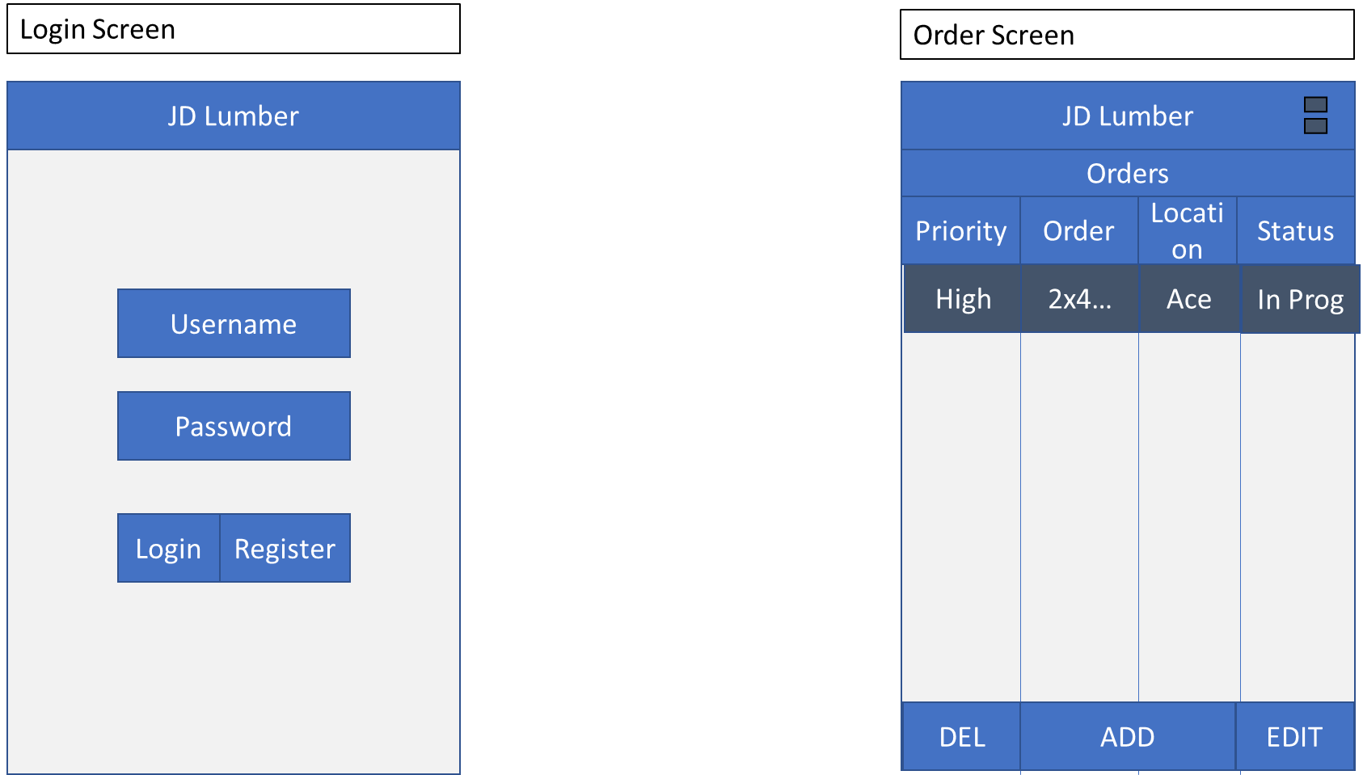

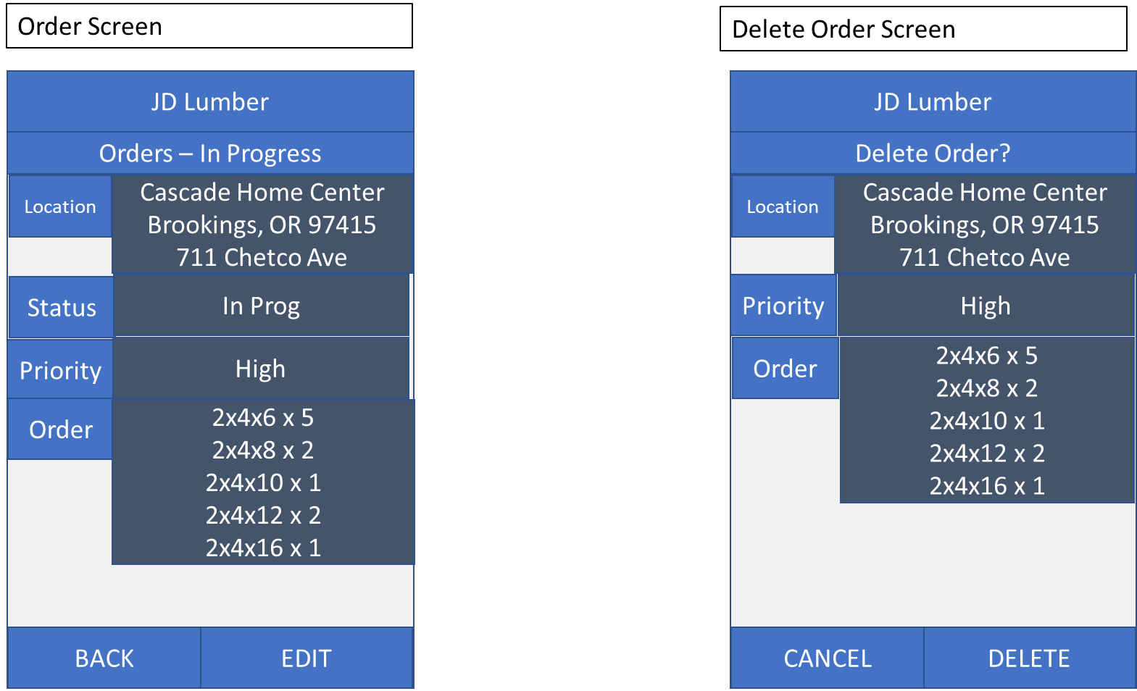

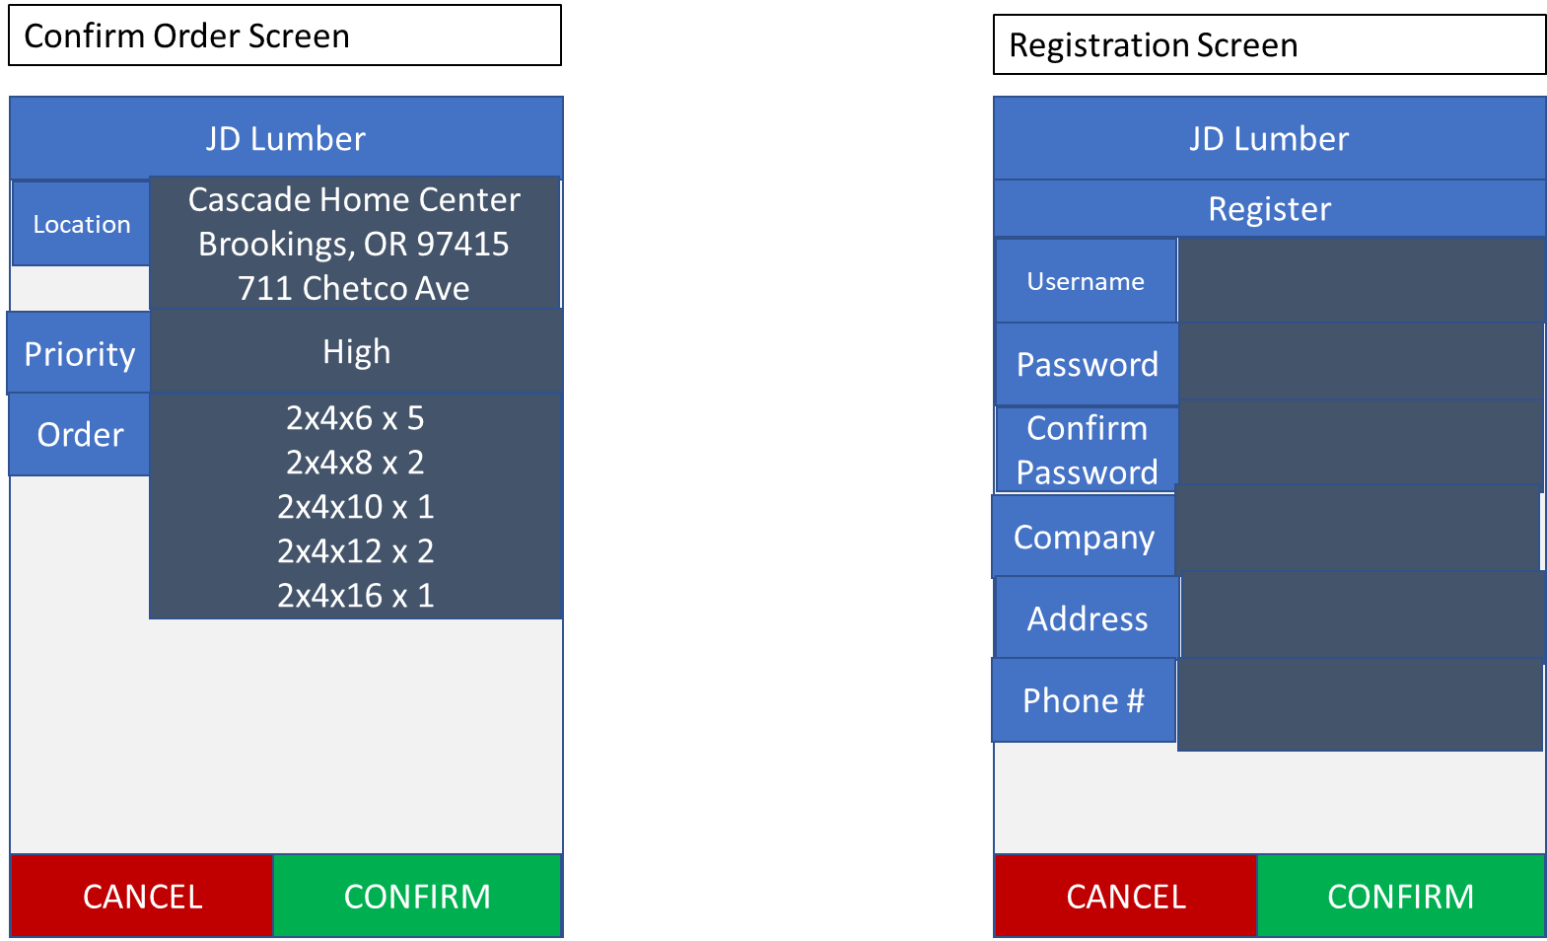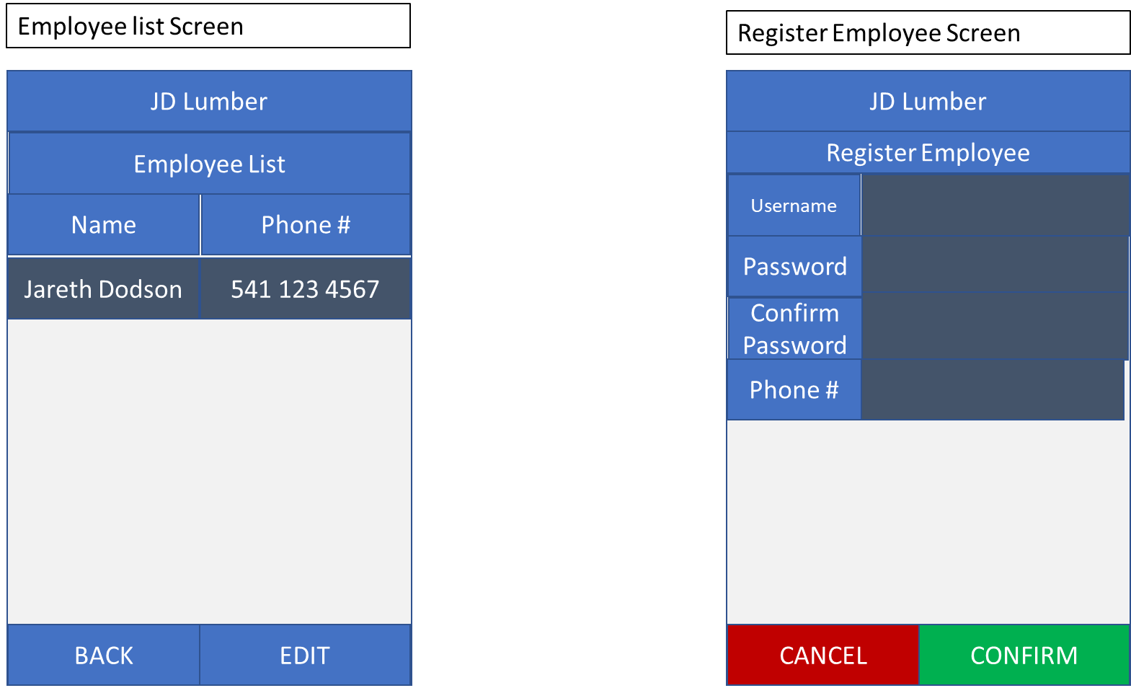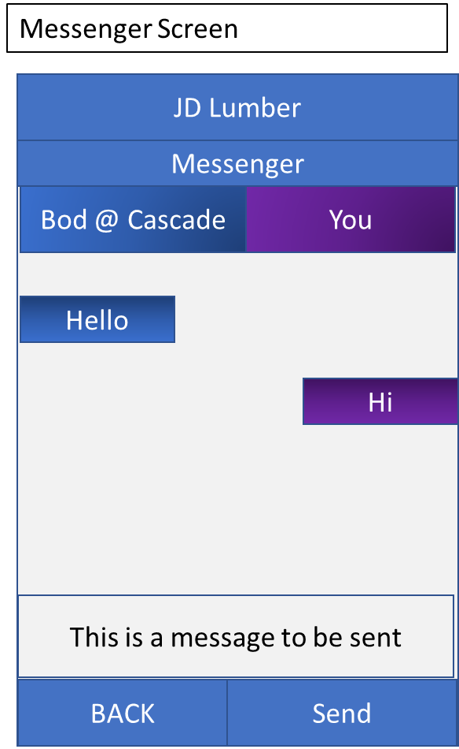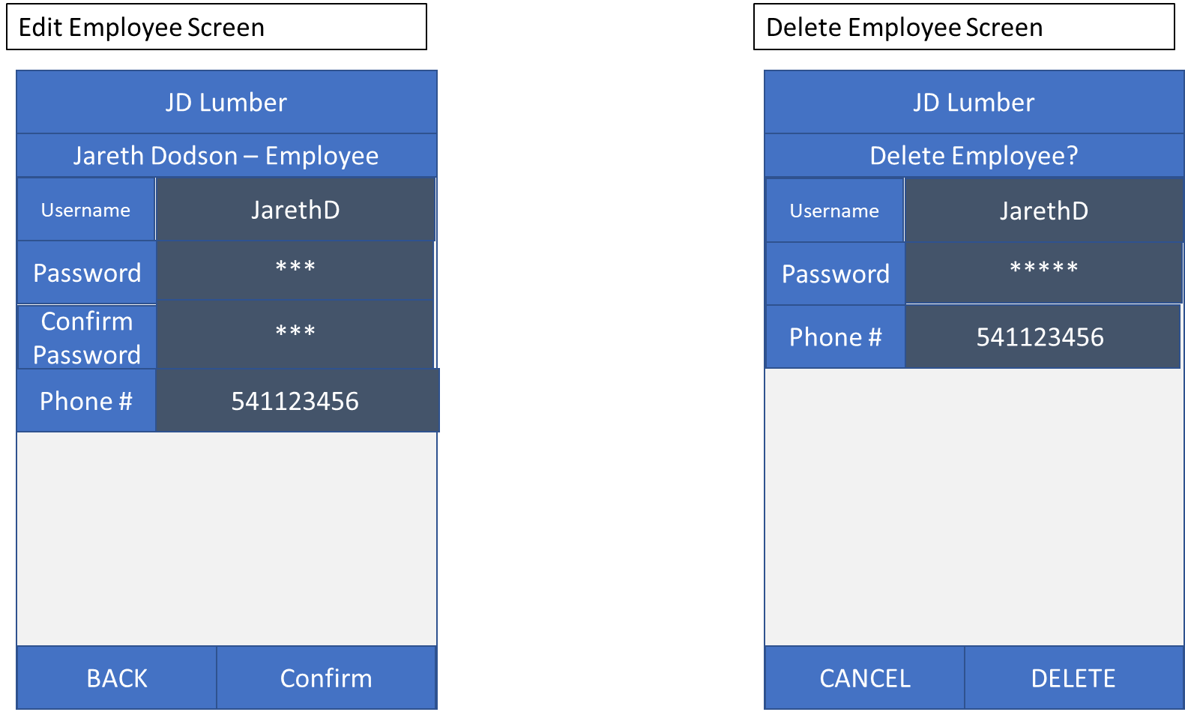

## 10.2 Desktop UI

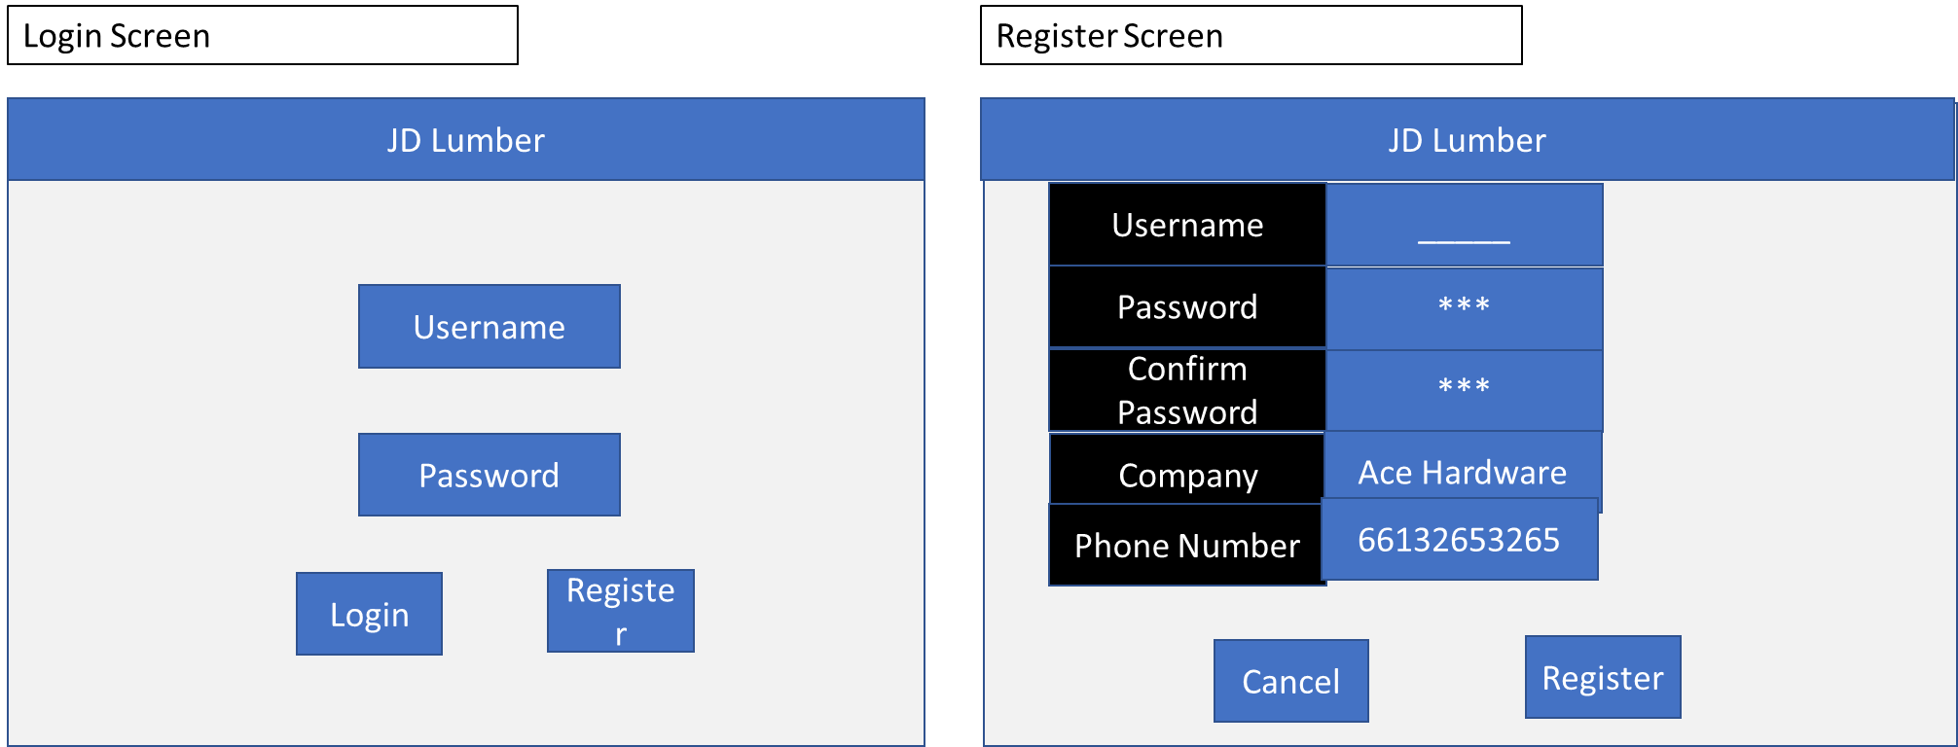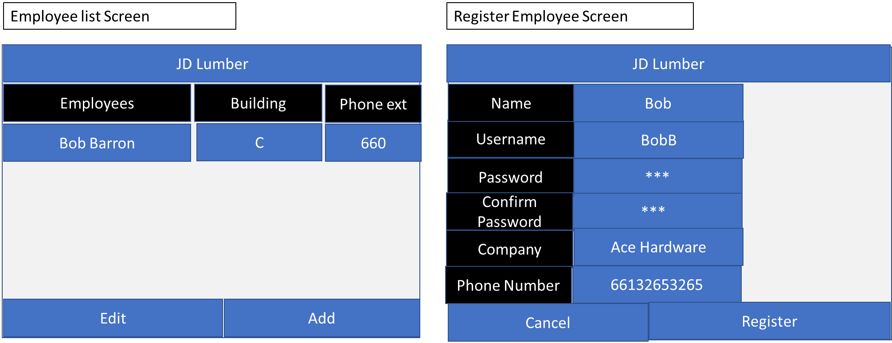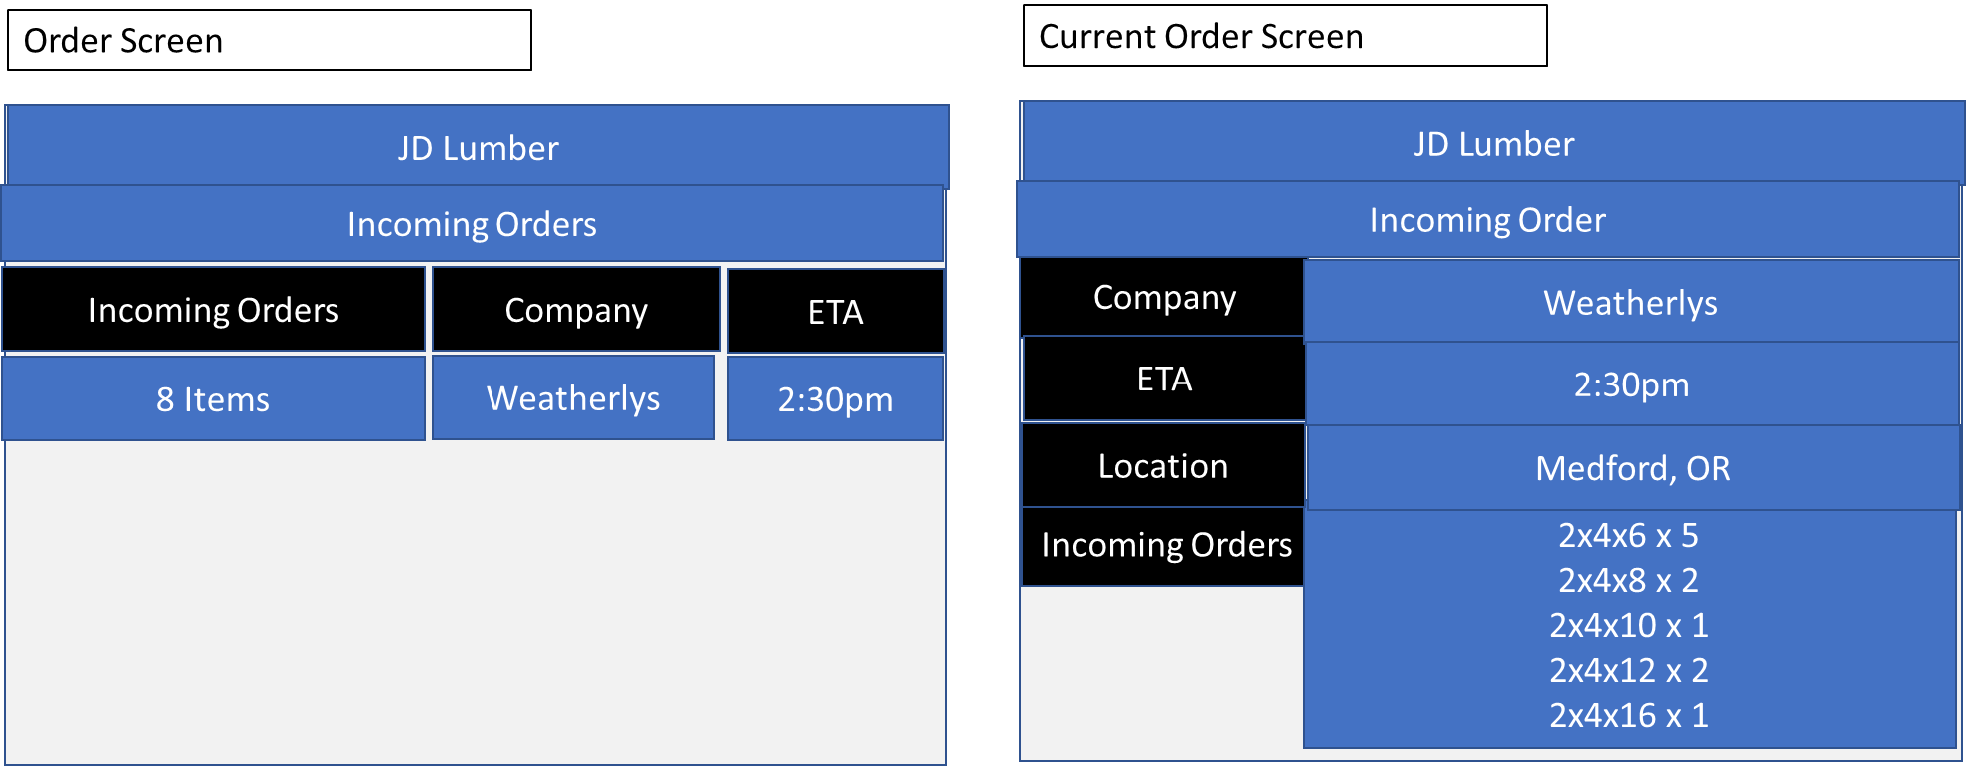

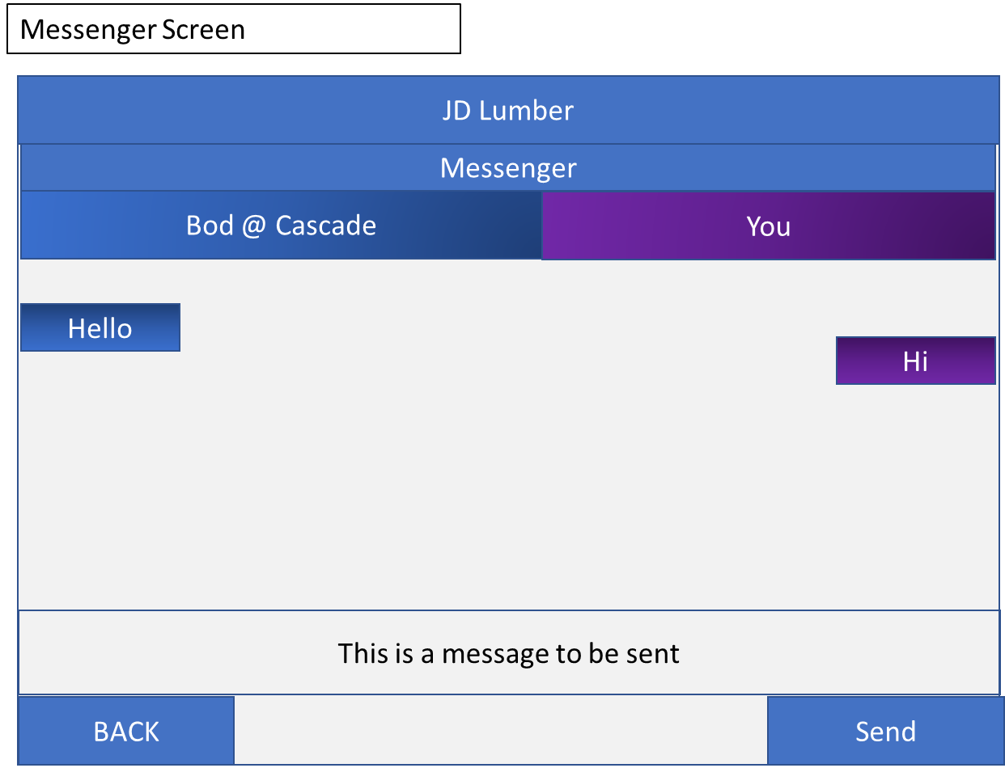

# 11. Appendix A

Business Rule 1 – Password Encryption